**National College of Ireland**

Higher Diploma in Science in Computing

**Distributed Systems**

**Terminal Based Assignment Assessment**

**(TABA)**

Saturday 4th May, 09:00 am to Tuesday 8th May, 23:55 pm

**Lecture: Mark Cudden**

Repository:

<https://github.com/sergio-oliveira-br/distsys>

Sergio Vinicio da Silva Oliveira

[**x23170981@student.ncirl.ie**](mailto:x23170981@student.ncirl.ie)

**1. Consider that you are designing a "Product Management" system that supports at least four operations.**

* **Explain and differentiate between the four kinds of service methods supported in gRPC.**
* **Include appropriate proto file definitions and sample code in your explanations.**
* **How would each type of method be used?**
* **How would these methods be defined in the proto file?**
* **What would the corresponding code look like?**

Just a little introduction.

In gRPC, it is possible for a client application to directly call a method in a server application on a different machine as if it were a local object, which simplifies the creation of distributed applications and services.

Is based around the idea of defining a service, specifying the methods, where I will explore a lit bit more, that can be called remotely with their parameters and return types.

The image below is a representation of the concept of connection.

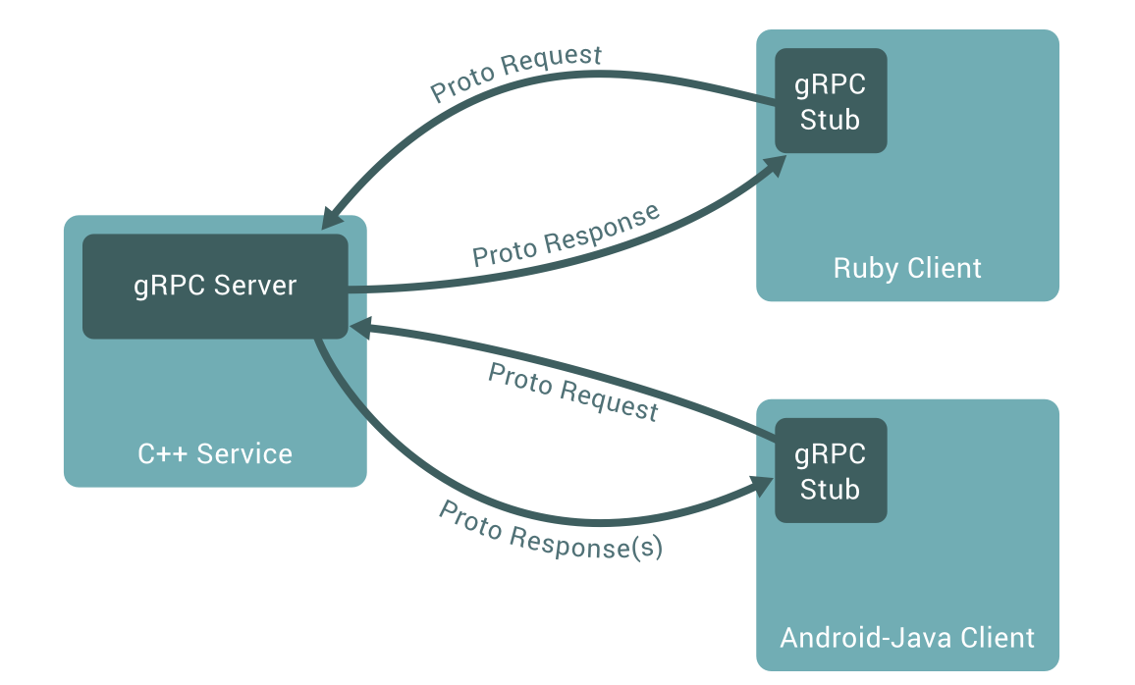

gRPC (2023) *Introduction to gRPC*. Available at: <https://grpc.io/docs/what-is-grpc/introduction/>

[Accessed 7 May 2024].

Implementing the gRPC concept.

Keep in mind that the theme will be built around a bookstore, and these are the attributes of the object of study.

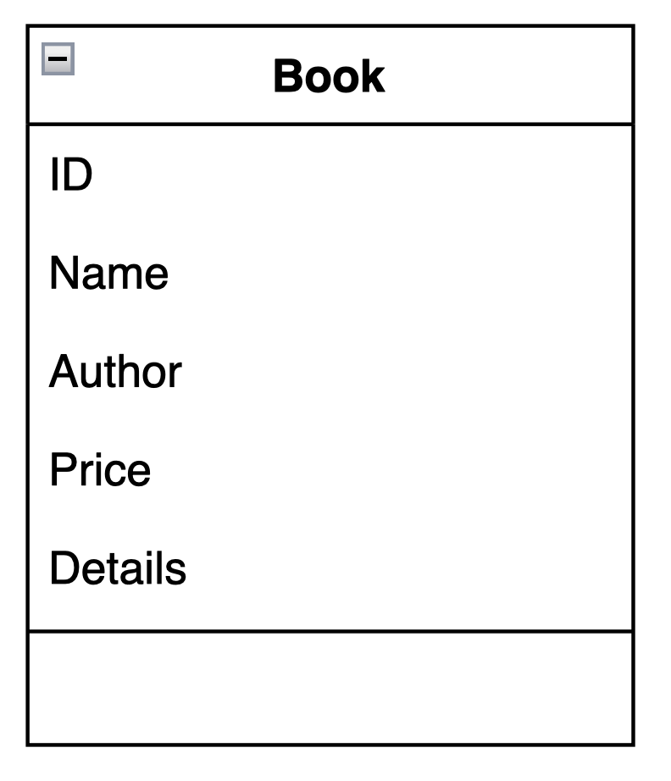

The image below represents the implementation of the SalesServices service using the Protocol Buffer version proto3, line 16.

To define a service in gRPC, we proceed as described in line 19. Then, the RPC methods can be defined in our service definition by specifying their request and response types, as we can see in line 22.

This service in particular, addresses the idea of Unary RPC, aiming to provide the user with details about a particular book.

As previously mentioned, the proto file also contains protocol buffer message type settings for all request and response types used in our service methods. Through line 26 represented the client side, and line 29 represented the server side, we establish these definitions.

The user request the information about one specific book using ID. Then, the server responds returning an information type String.

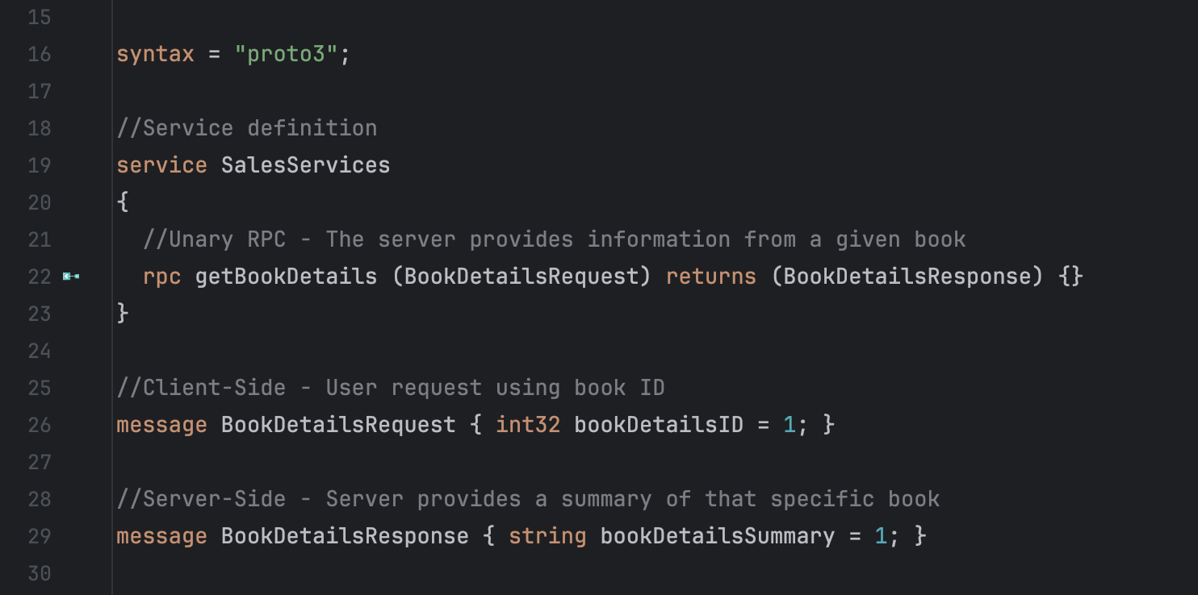

Introducing another service implementation, this one focused on Client-Side Stream and Bidirectional Stream.

Through the image below, we can observe a structure similar to that previously mentioned. But this time the service definition has two different methods.

Line 23 illustrates the implementation of the Client-Side Stream, and in line 27 Bidirectional Stream implementation.

In both instances, the methods' definitions contain the keyword “stream”, which means the existence of transmission.

The method addBookImages( ) proposes the idea that the user can send a collection of images related to a specific book to the server, and the server will respond with a single response. This concept is related to the Client-Side Stream approach.

Nonetheless, the method insertBulkDiscounts( ), allows the user to make numerous adjustments to the individual prices on many books, the server then responds individually to each request.

It's important to point out that the proposal is designed to accommodate a large number of individuals.

To illustrate the idea, consider that a 10% reduction will be implemented in all books in a certain segment.

In contrast to the Client-Side Stream, Bidirectional approach, allows the server responds with a single response. This time, we will be given individual confirmation for each adjustment made, as well as the freedom of individual adjustments.

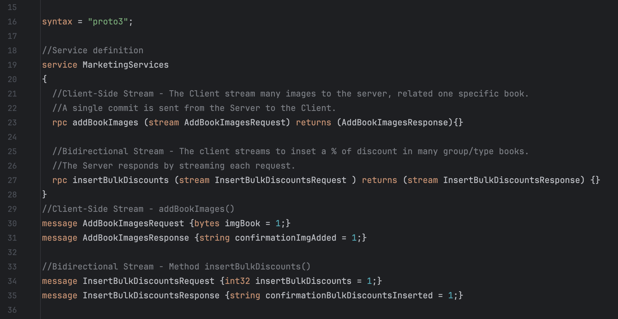

The Server Side Stream is the last method to be shown.

Through this service, the client sends a request to the server and gets a stream to read a sequence of messages back. The stream is read by the client until all messages have been read. The image bellow shows the service definition. Note that keyword “stream” is placed after returns.

This service implements the process where the user by sending only one request, gets from the server all books available.

The request and response are both executed using a string type.

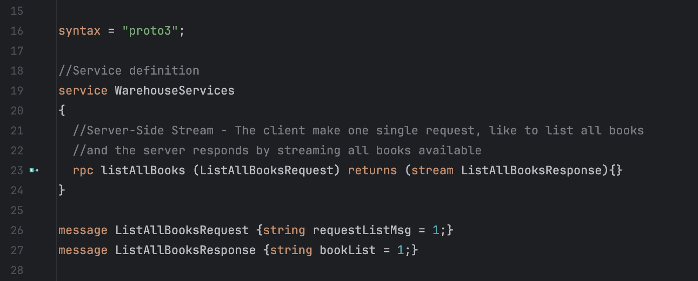

**2. Explain the “Product Management” service designed in Q.1 (protos) with the Interface Definition Language (IDL). Then in the context of your implementation, explain with examples.**

1. **What is the purpose of an Interface Definition Language?**

IDL is a specification that describes the API of a software component in a language-neutral manner.

Google developed Protobuf, a method that is non-platform specific and can be used to deserialize and serialize structured data between two services. It is also capable of defining the contract for communication between two systems.

According to protobuf.dev, protocol buffers are "Google’s language-neutral, platform-neutral, extensible mechanism for serializing structured data – think XML, but smaller, faster, and simpler. You define how you want your data to be structured once, then you can use special generated source code to easily write and read your structured data to and from a variety of data streams and using a variety of languages."

Vinoth Selvaraj (2020) Protocol Buffers — A Simple Introduction. Available at: <https://vinsguru.medium.com/protocol-buffers-a-simple-introduction-f0f4167287e0#:~:text=Overview%3A,interface%20description%20language%20(IDL)> [Accessed 08 May 2024].

1. **Why do we need openness?**

To promote the capacity to integrate and interoperate in a transparent manner across various systems and technologies, in addition enables freedom of choice, flexibility, and innovation in building software applications and services.

**3. Discuss mitigation strategies for the following Fallacies of Distributed Computing.**

1. **The Network is Reliable?**

In the face of the uncertainty and complexity of networks, accepting failure as something natural is crucial to network reliability. Developing the system to be fault-tolerant is essential. Recognizing the inevitability of failures in complex systems, we can design measures that strengthen the resilience of the network, ensuring its stability and functionality in adverse situations.

The image below shows the load balancer manipulating the servers to ensure availability and service continuity for the user.

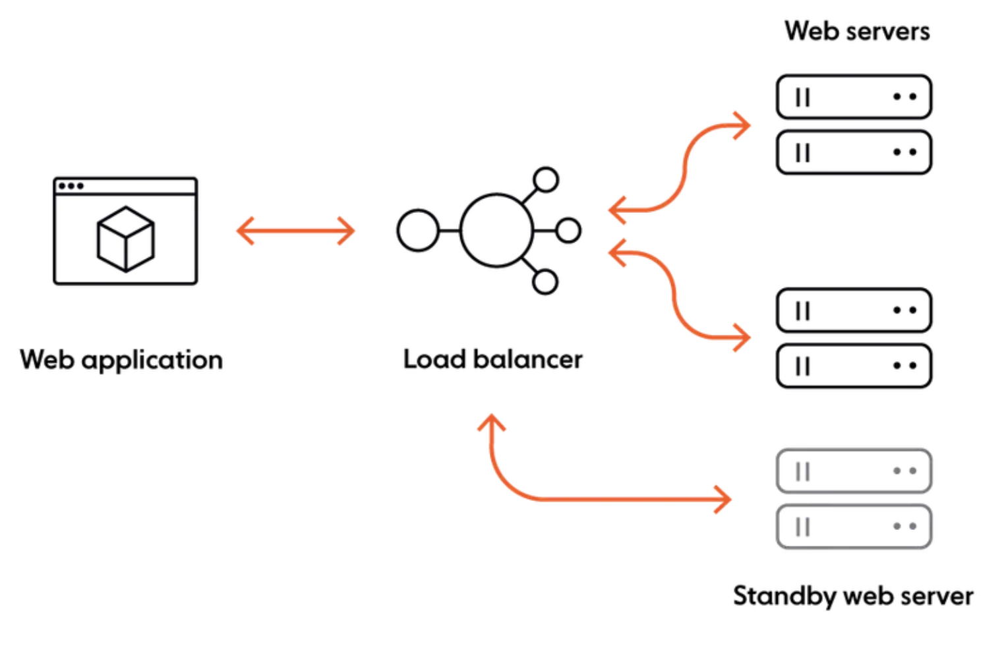

Ably (2022) Navigating the 8 fallacies of distributed computing. Available at: [**https://ably.com/blog/8-fallacies-of-distributed-computing**](https://ably.com/blog/8-fallacies-of-distributed-computing)[Accessed 08 May 2024].

1. **Latency is zero.**

One strategy to reduce latency is data compression. By compressing the data before sending it over the network, it is possible to reduce the size of the packets and, consequently, the transmission time. In addition, the use of efficient compression algorithms can minimize data quality loss.

The application of protocols such as TCP, UDP, in the case of gRPC, HTTP/2, which offer different compensations between reliability, speed and overload. In addition, it is important to take into account the network topology and routing of your system and select the most suitable locations and paths for your components.

Ably (2022) Navigating the 8 fallacies of distributed computing. Available at: [**https://www.linkedin.com/advice/3/how-can-you-address-latency-distributed-system-ylhbc?lang=pt&originalSubdomain=pt**](https://www.linkedin.com/advice/3/how-can-you-address-latency-distributed-system-ylhbc?lang=pt&originalSubdomain=pt)

[Accessed 08 May 2024].

1. **Bandwidth is infinite.**

While latency is the speed at which data travels from point A to point B, bandwidth refers to how much data can be transferred from one place to another in a certain timeframe.

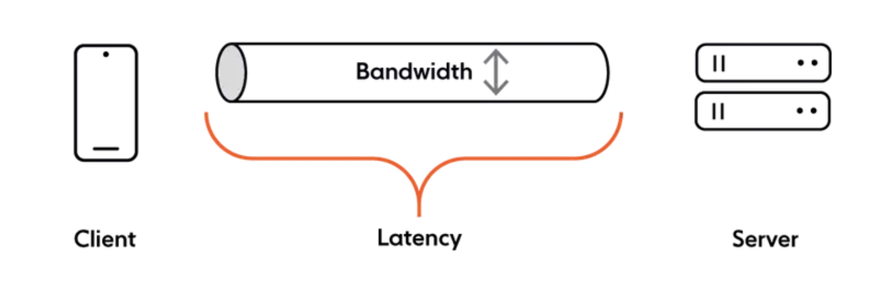

There are several ways to enhance the bandwidth, and gRPC protocols like HTTP/2, support multiplexing, a technique that improves bandwidth utilization by allowing you to combine data from several sources and send it over the same communication channel/medium.

Ably (2022) Navigating the 8 fallacies of distributed computing. Available at: [**https://ably.com/blog/8-fallacies-of-distributed-computing**](https://ably.com/blog/8-fallacies-of-distributed-computing)[Accessed 08 May 2024].

**4. By using the MQTT protocol implement in Java the Publisher - Subscriber parts of the following application:**

**Your application simulates a smart office environment, where sensors emit different structural and air properties about the site.**

**Publisher One:** publishes messages every second about the room, like the floor/room/temperature (e.g 17 C) and the floor/room/humidity (e.g. 25%).

**Publisher Two:** publishes messages about the floor every half second,like the floor/light/ID (e.g ON) and the floor/window/location (e.g. OPEN/CLOSE).

1. **Implement these 2 publishers and demonstrate the sending of messages on these topics and subtopics.**

The publishers' implementation can be seen in the images below.

To enhance the efficiency of the organization, I divided each publisher into classes with a distinct focus.

All the queues created. <http://localhost:15672/#/queues>

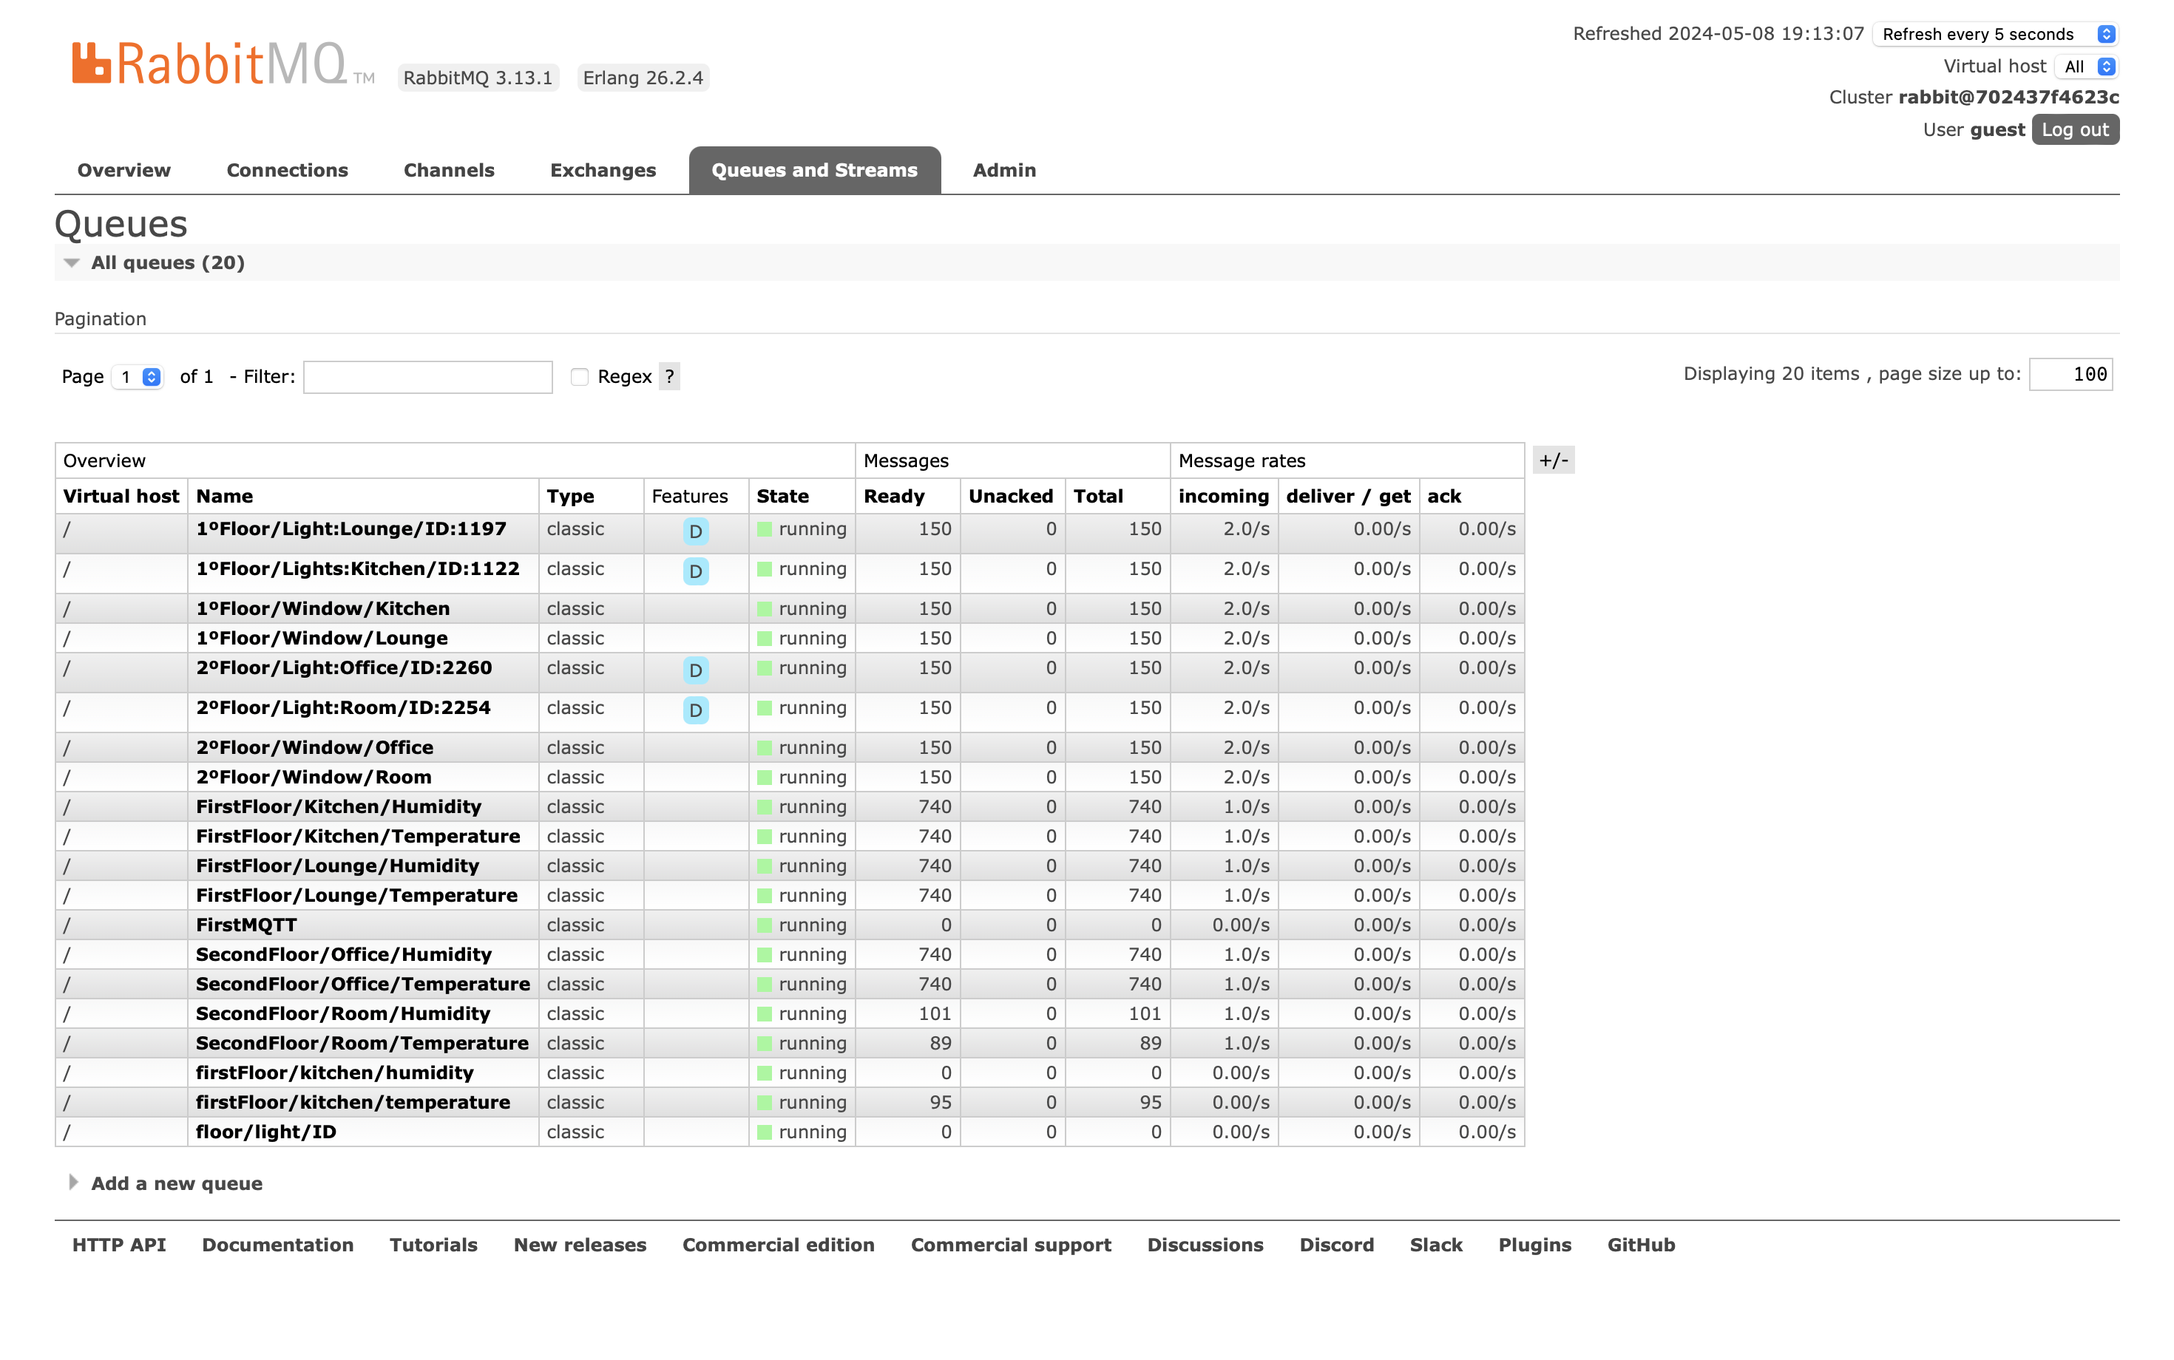

Publish One, Humidity (%)

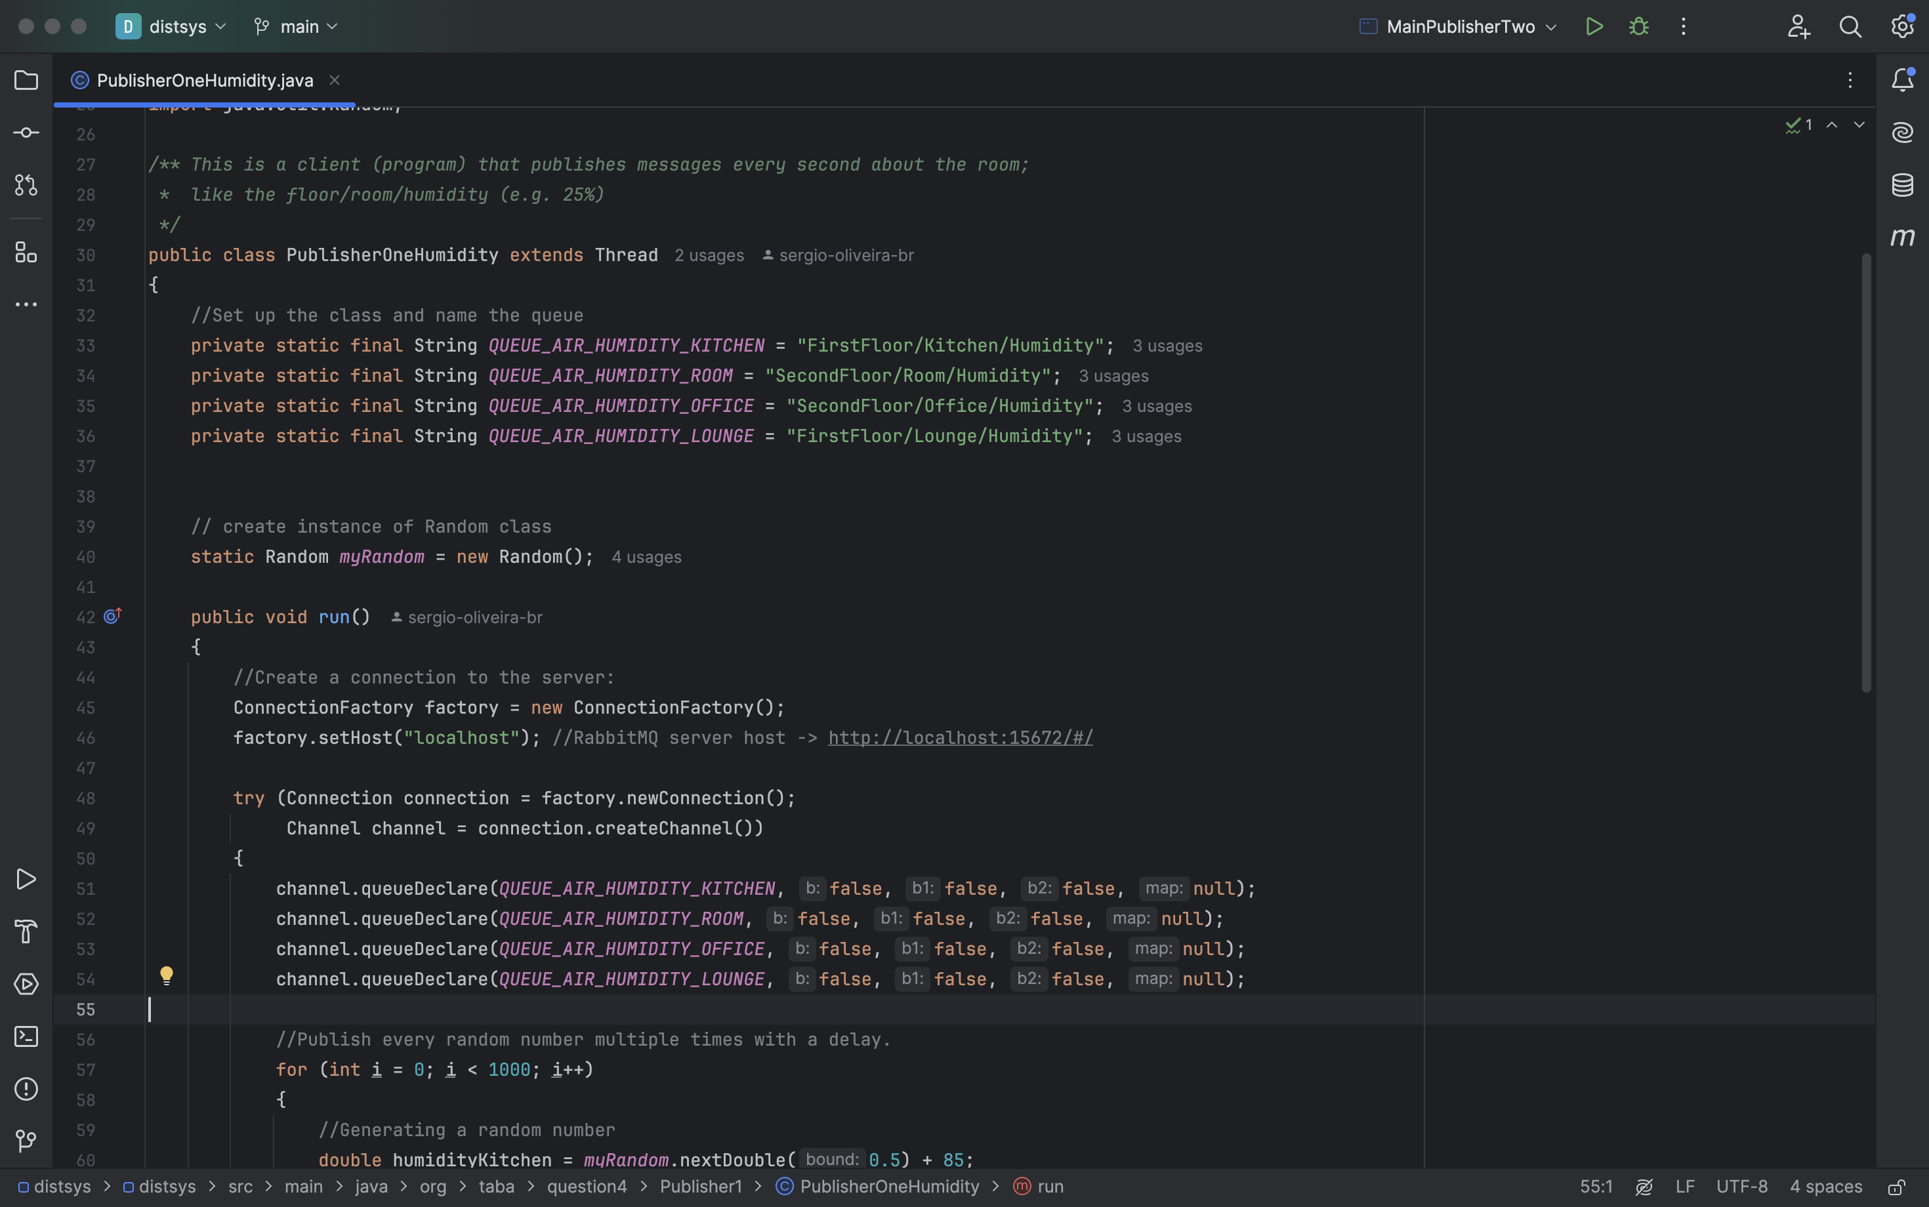

Publisher One – Temperature (ºC)

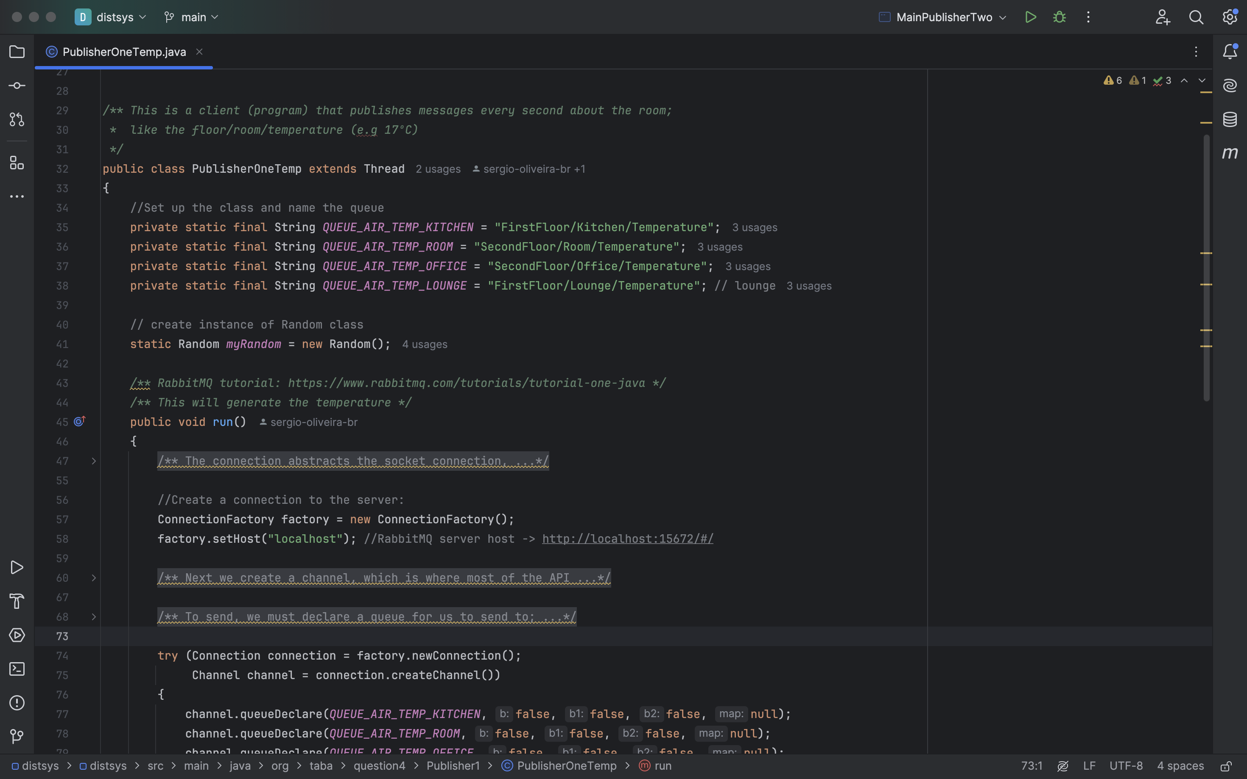

Main Method Publisher One

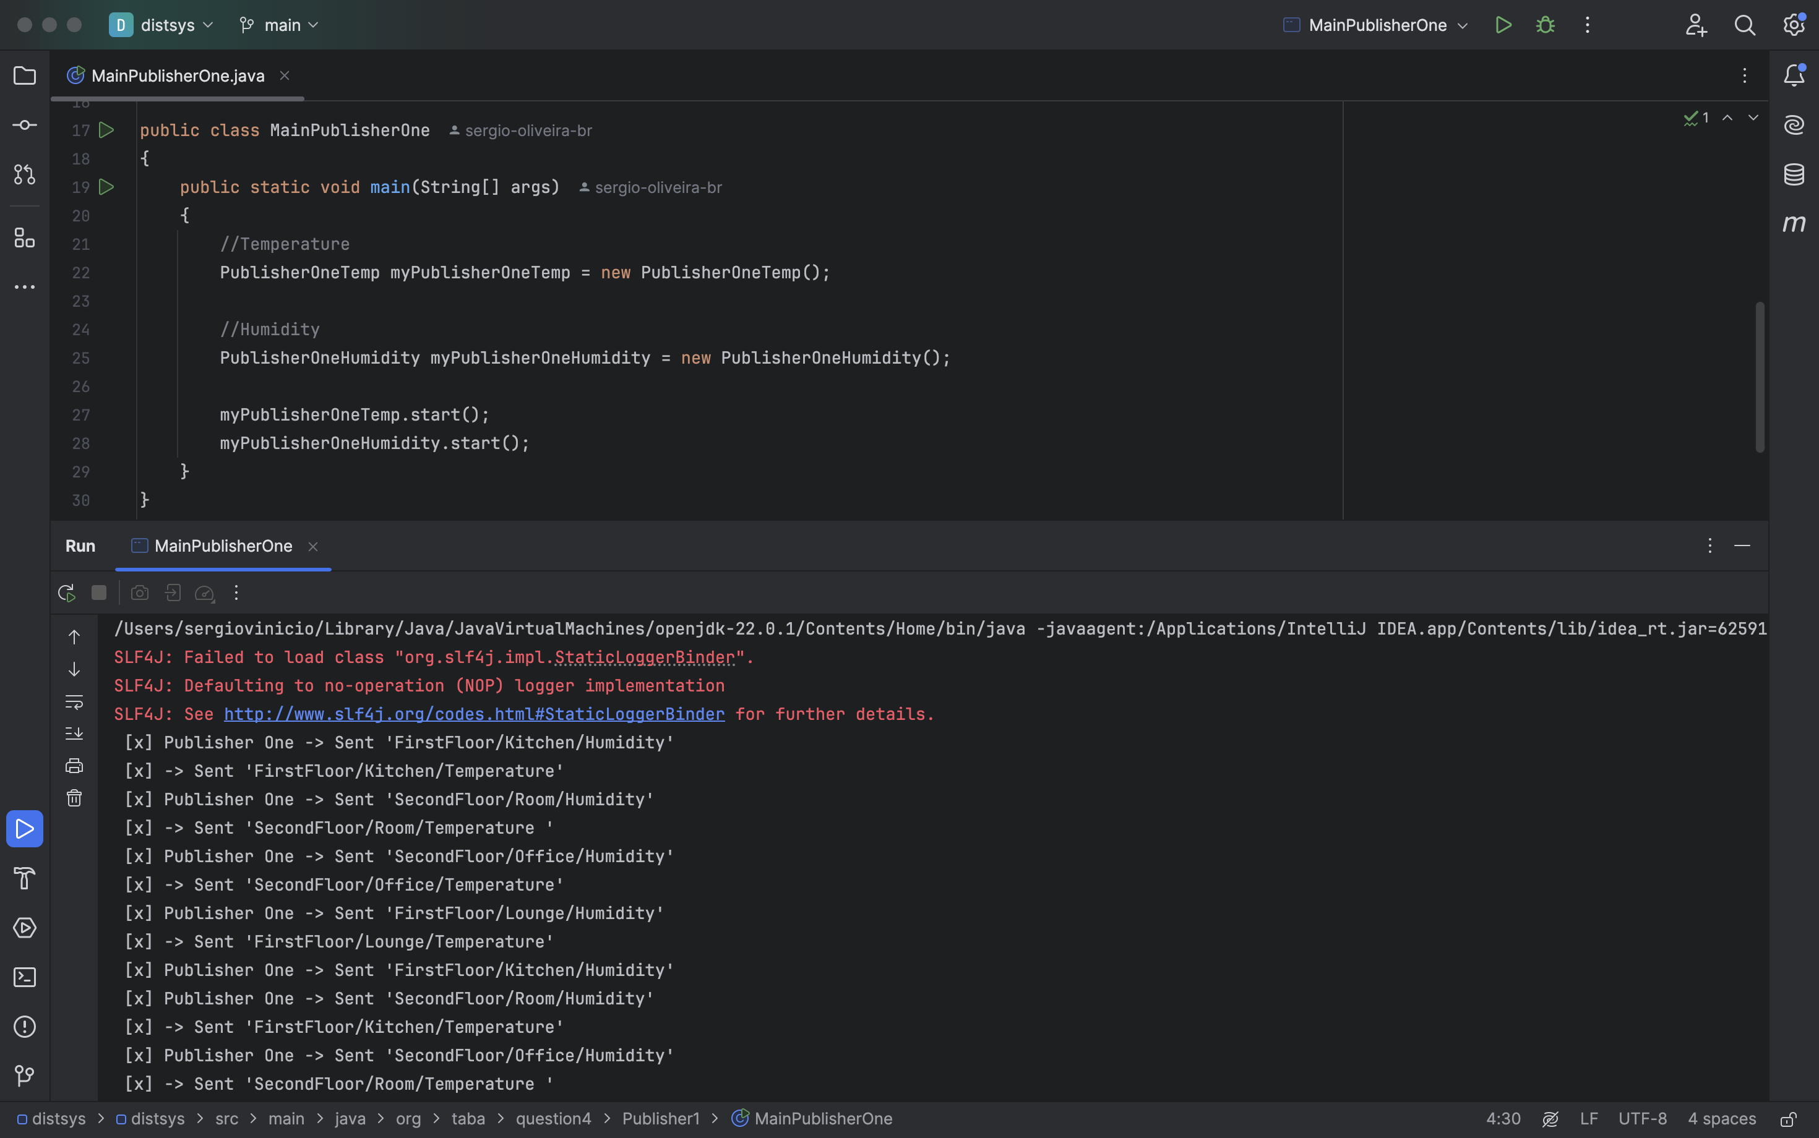

Publisher Two – Lights

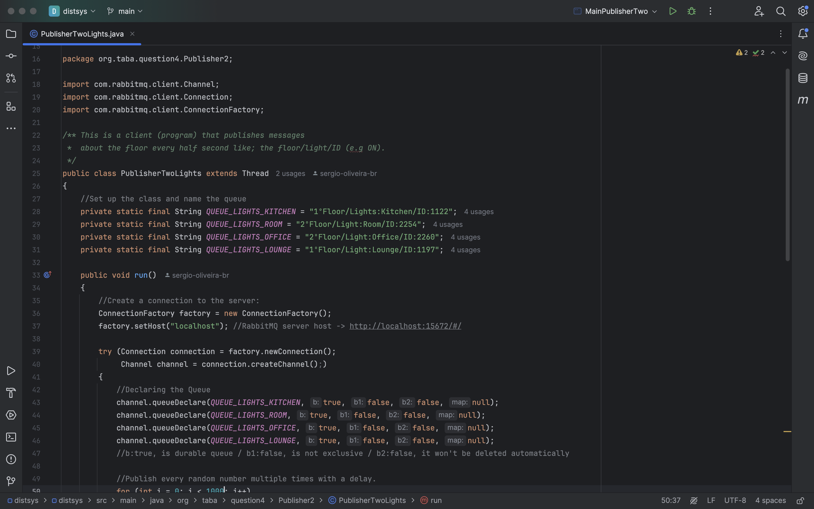

Publisher Two – Window

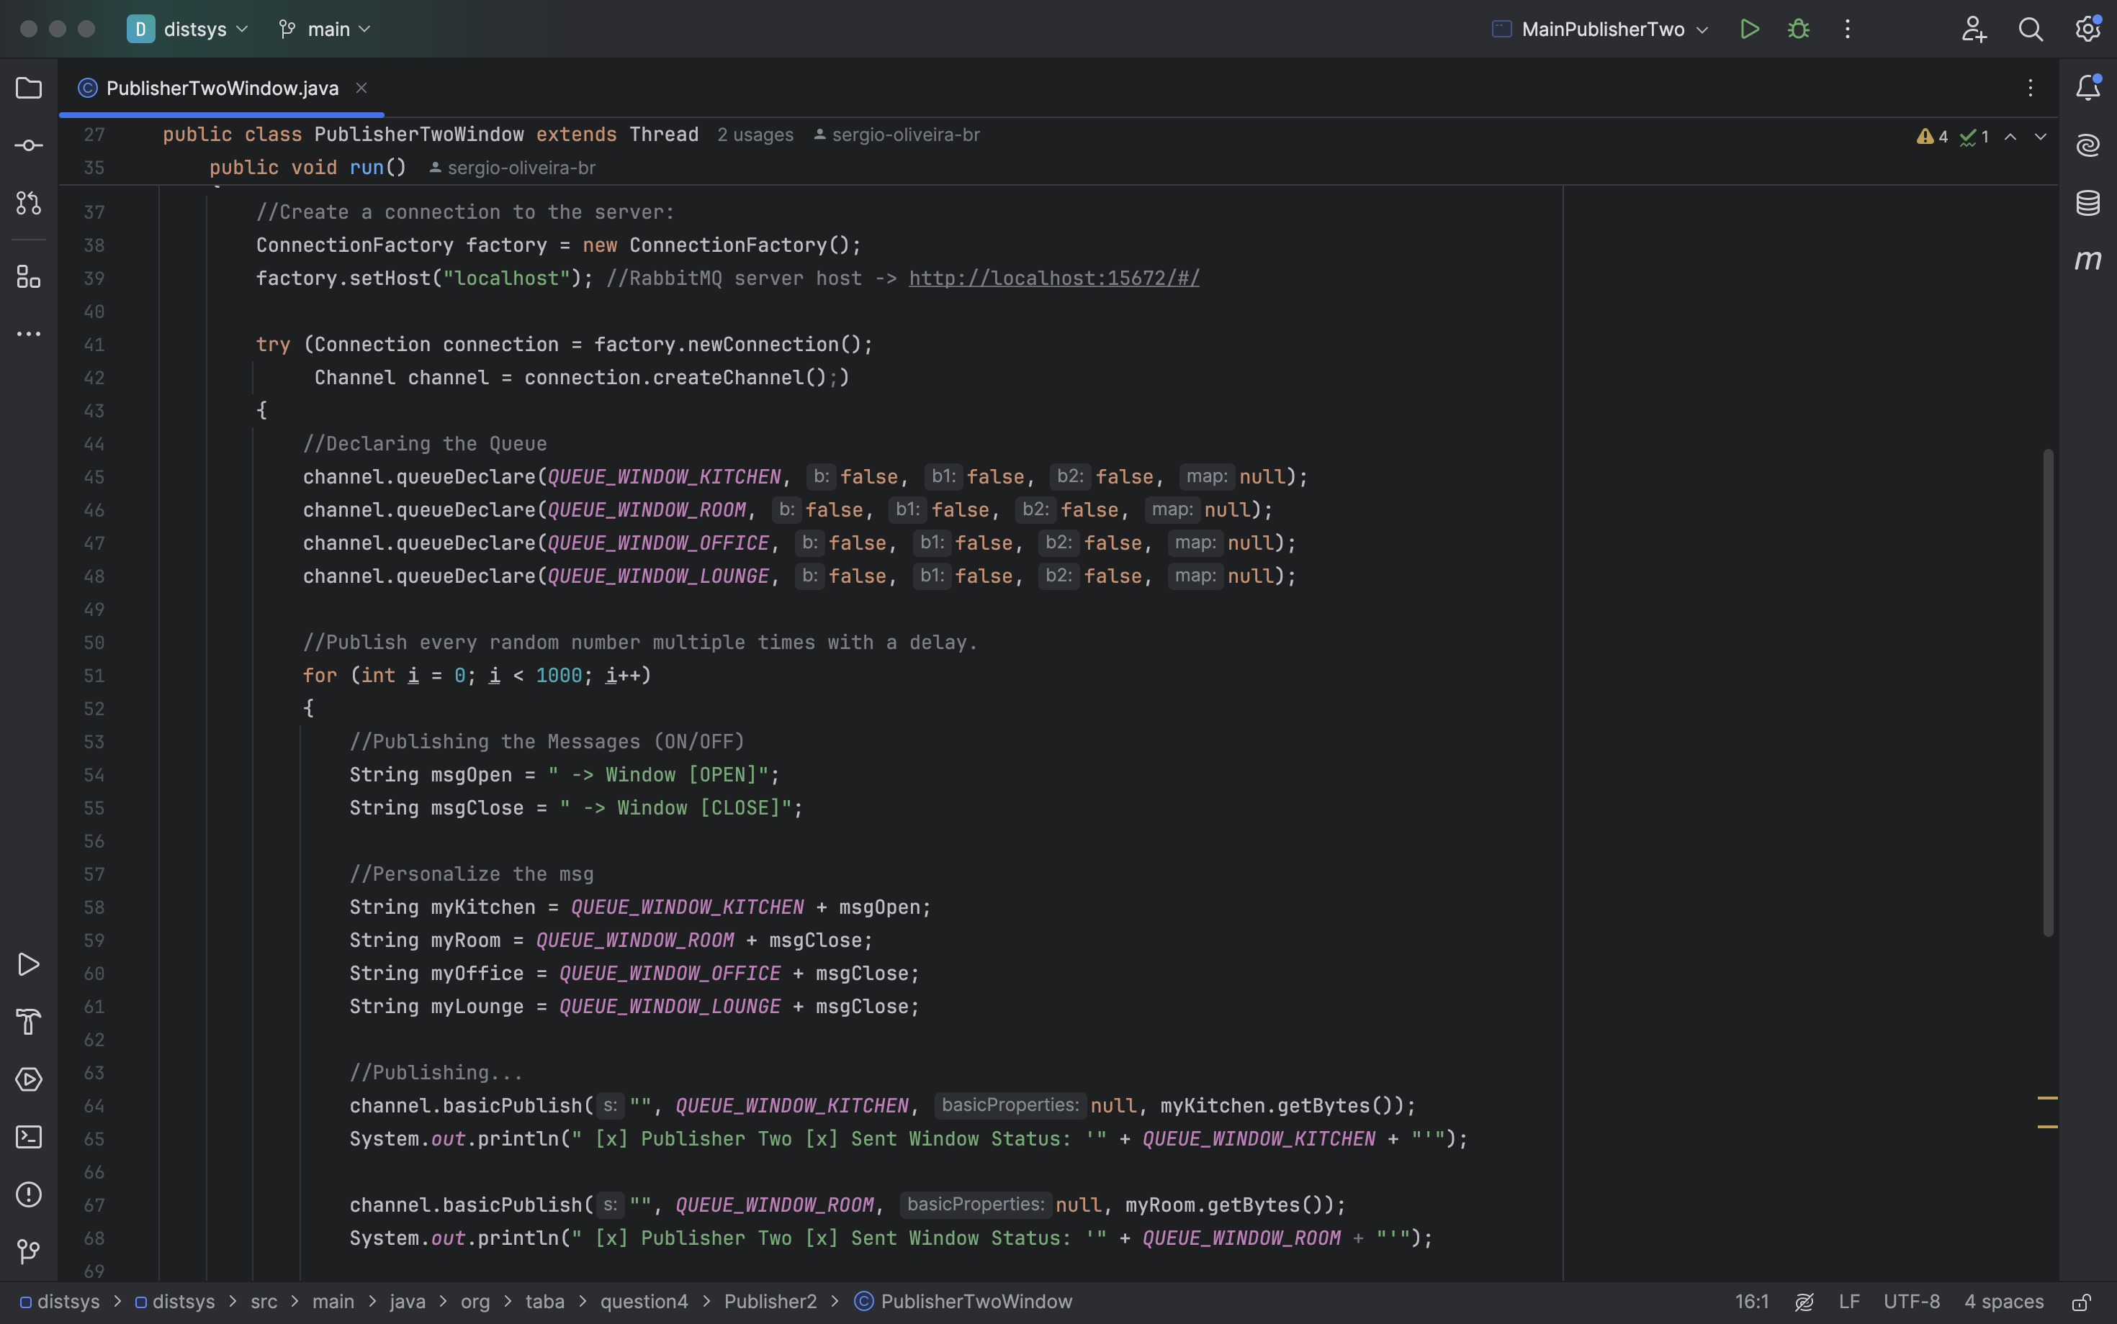

Main Method Publisher Two

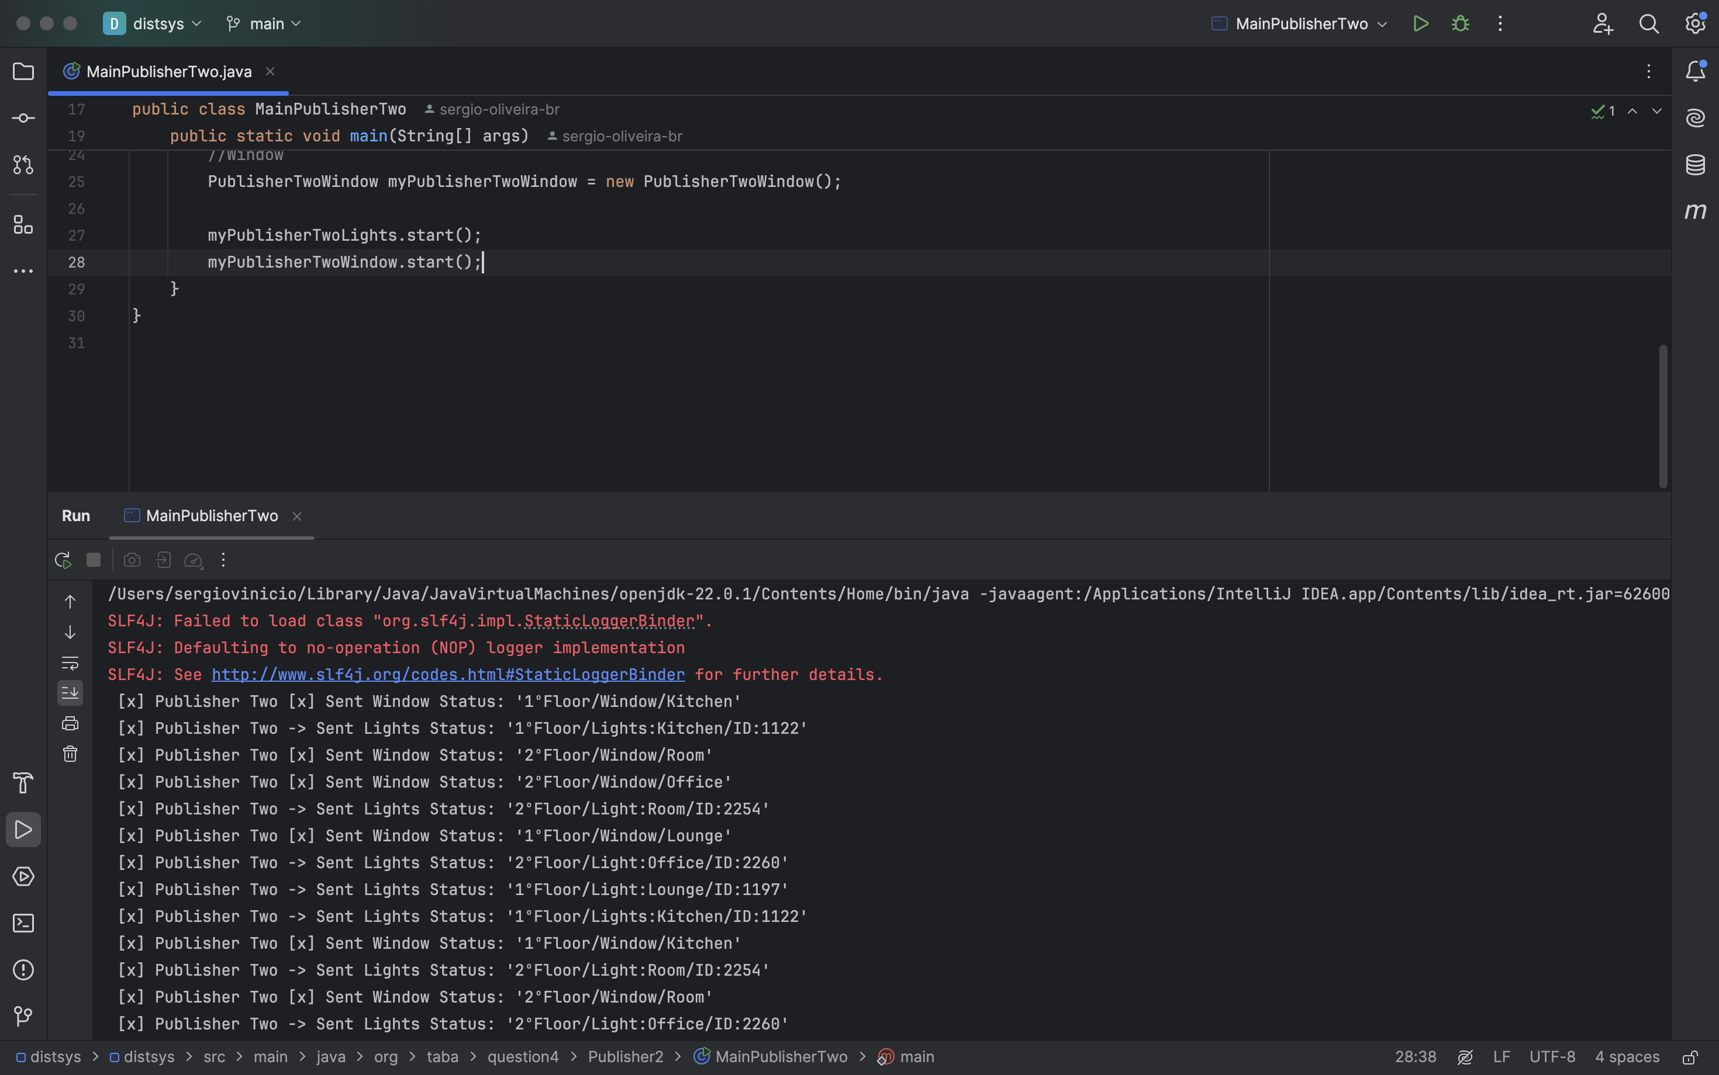

Run different subscribers to listen to messages:

1. **Strictly messages related to a floor/room/temperature.**

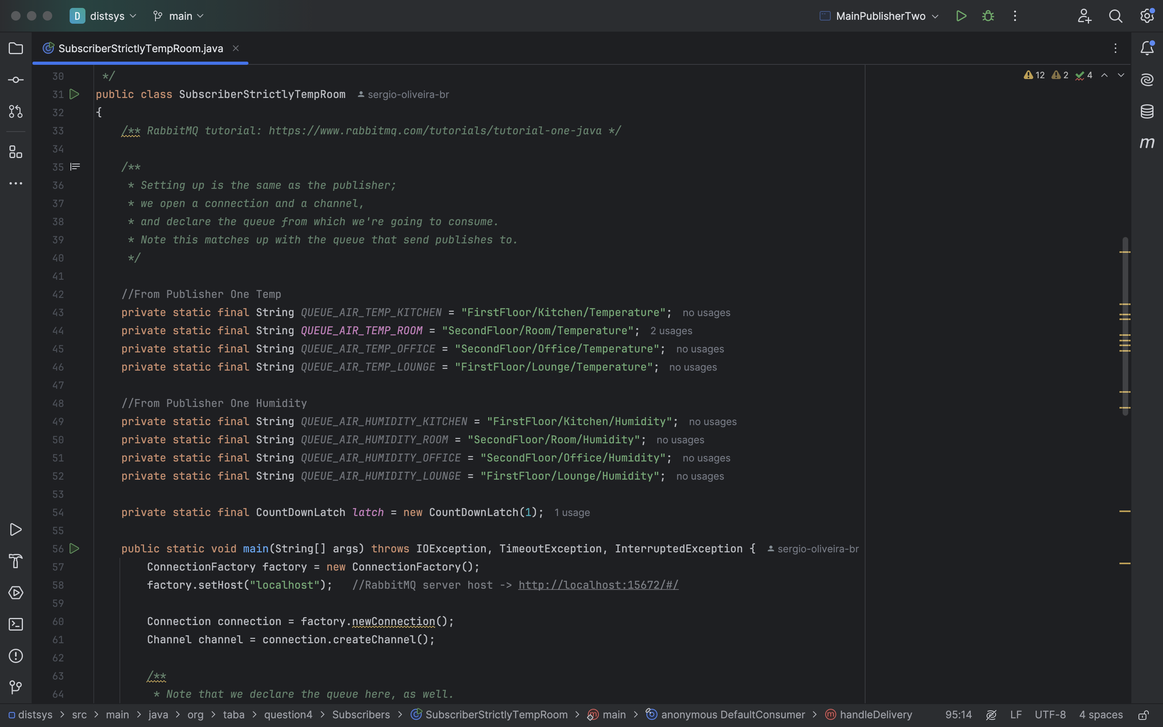

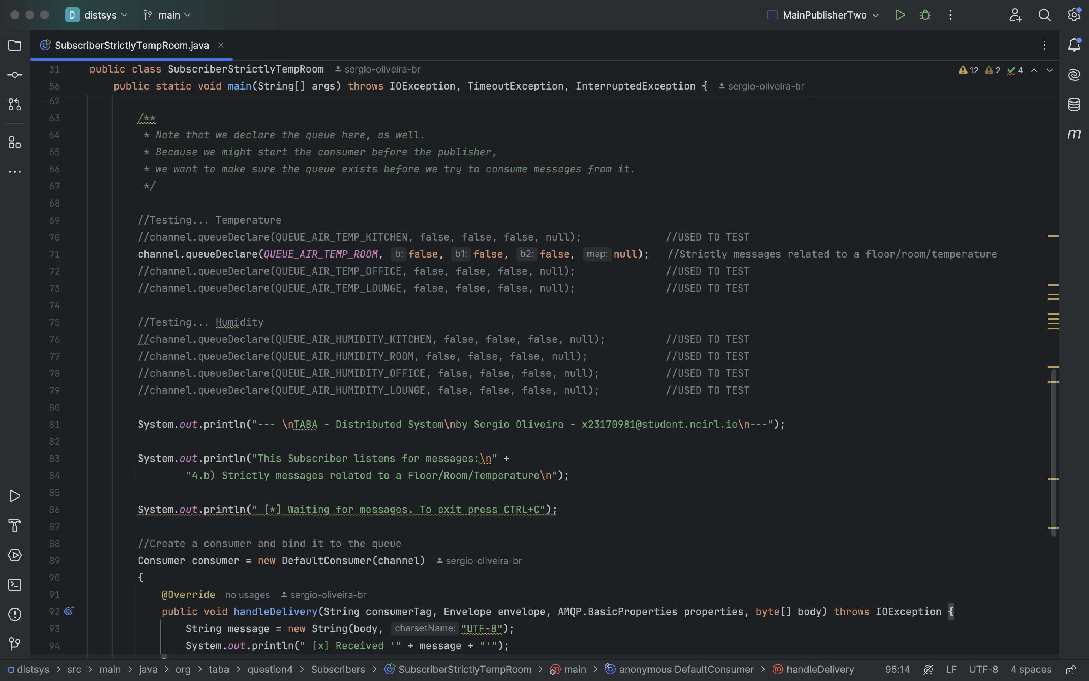

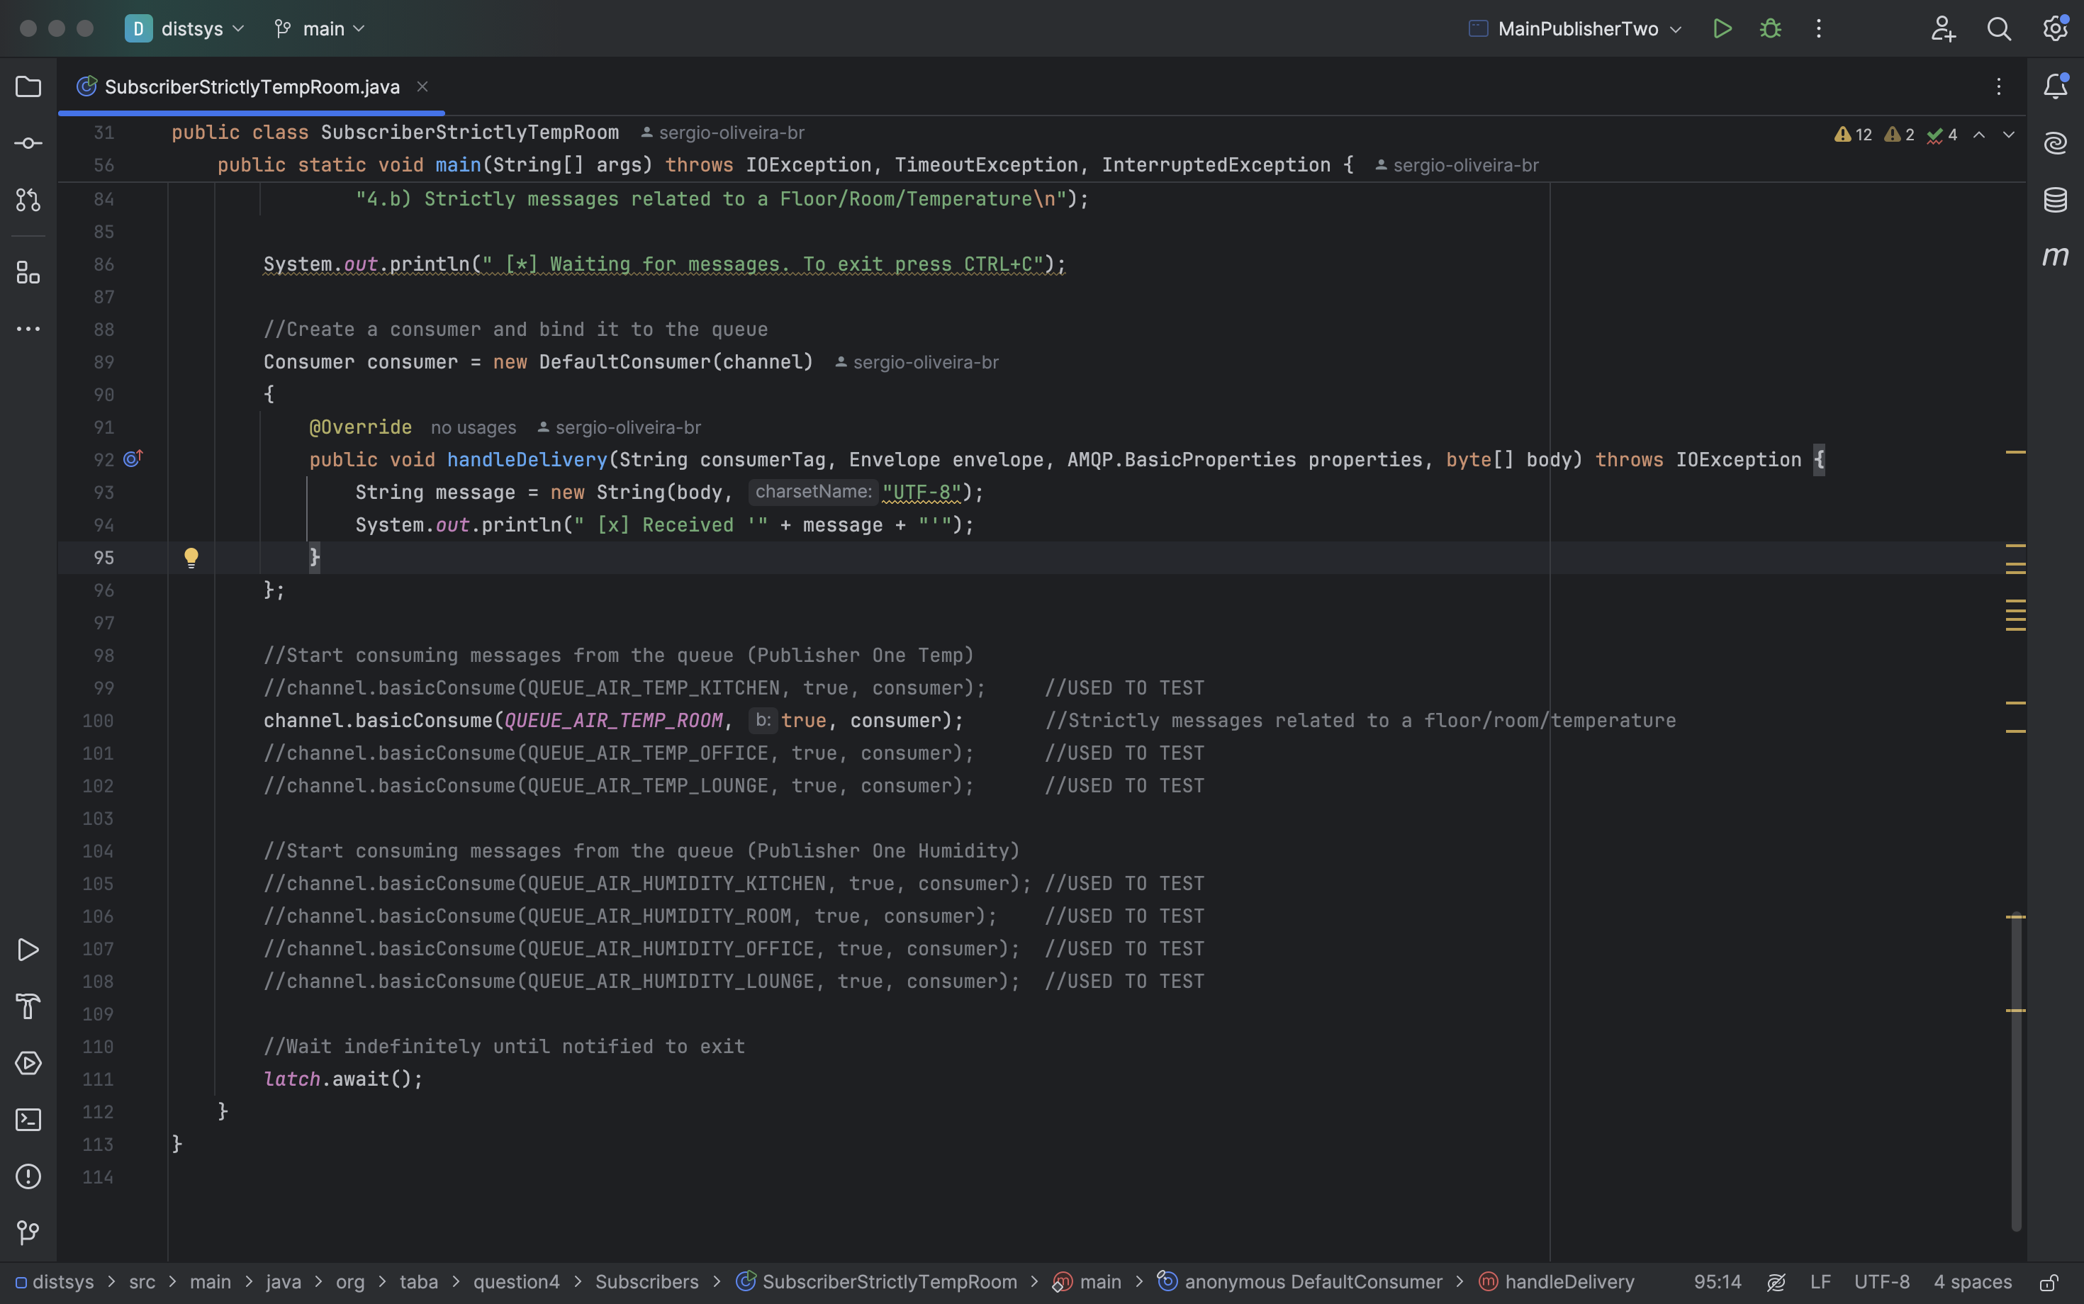

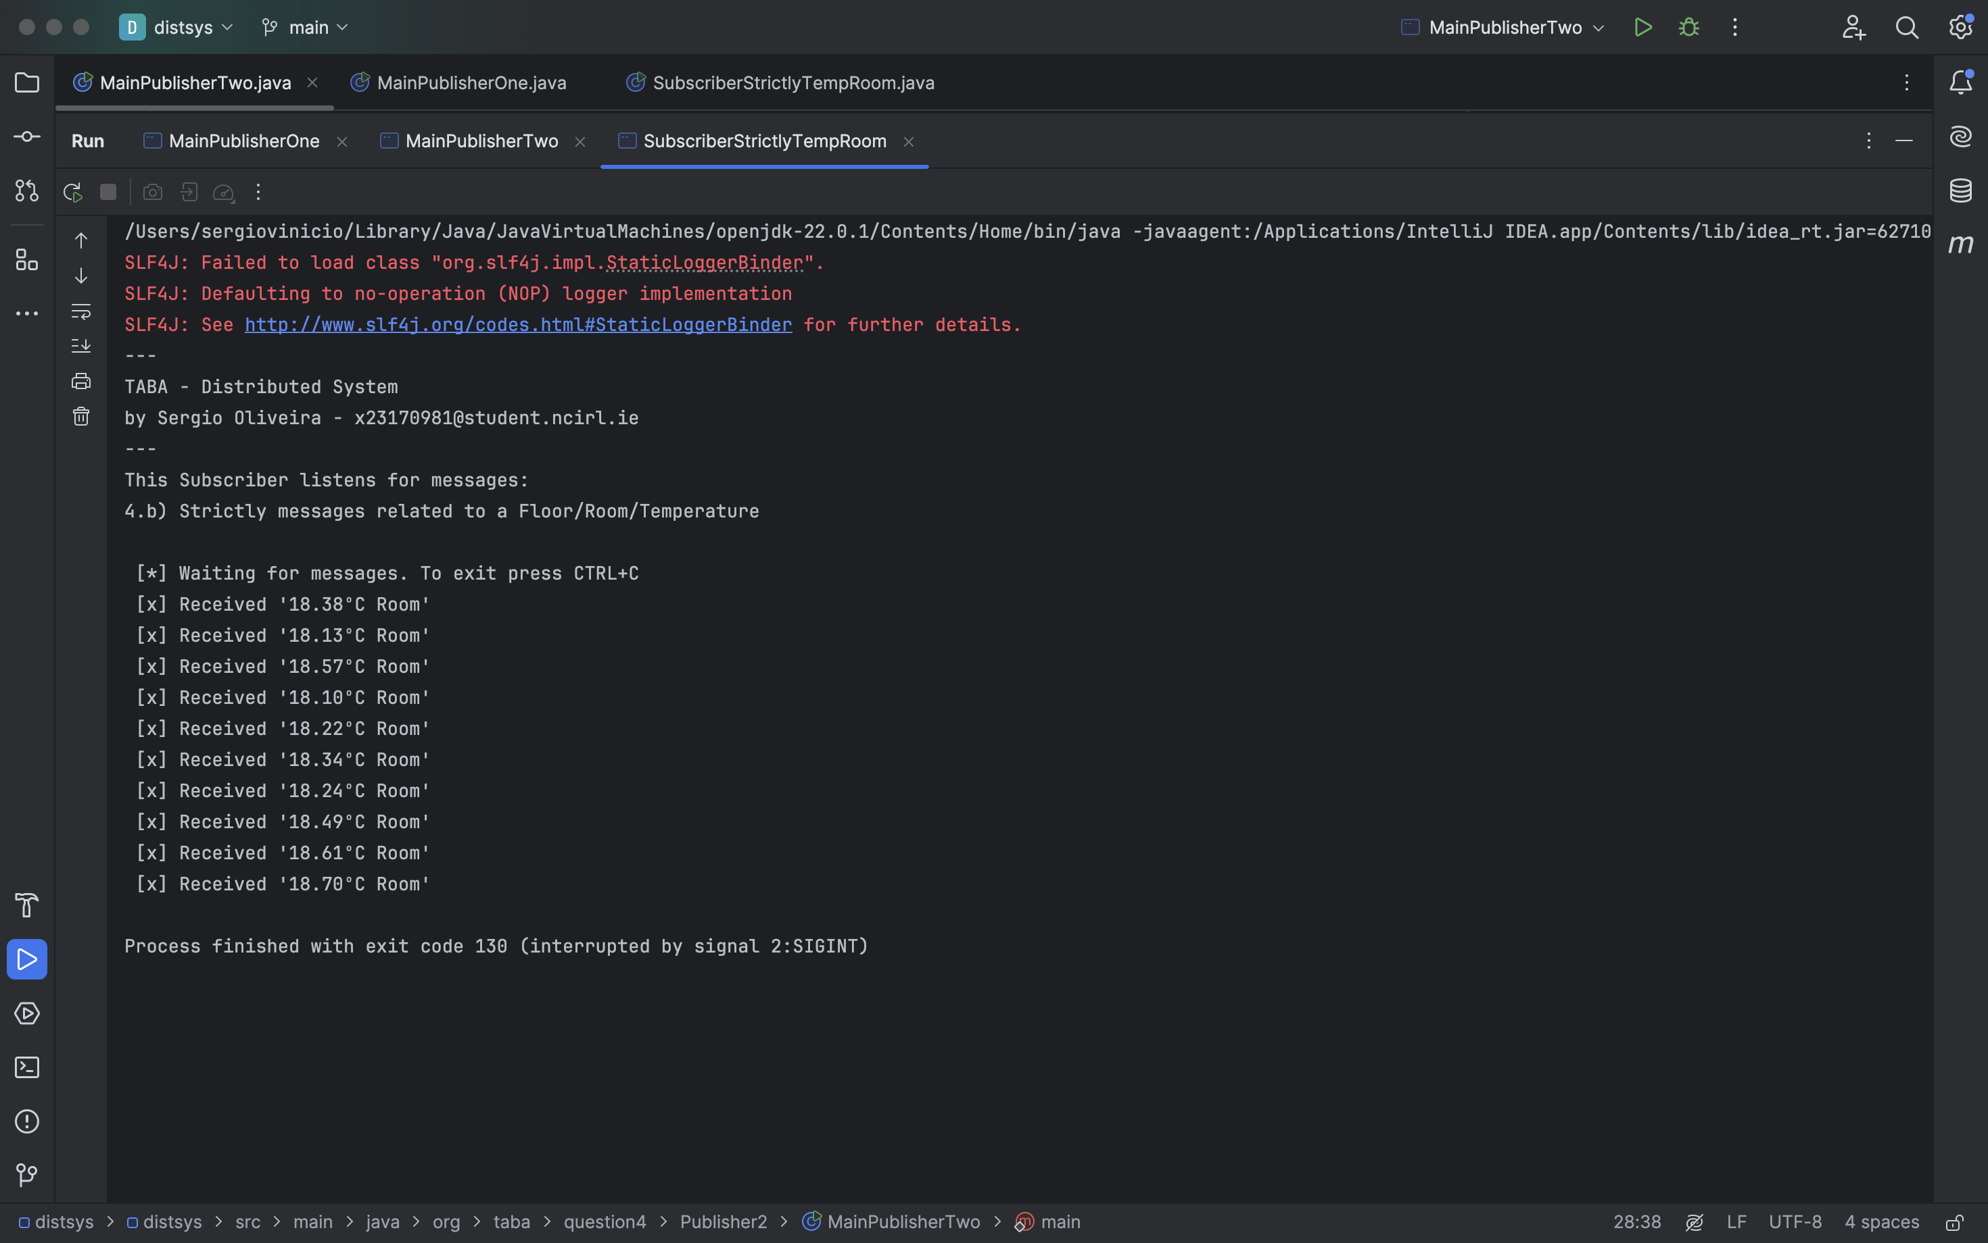

1. **Any messages that are related to room (including its subtopics)**

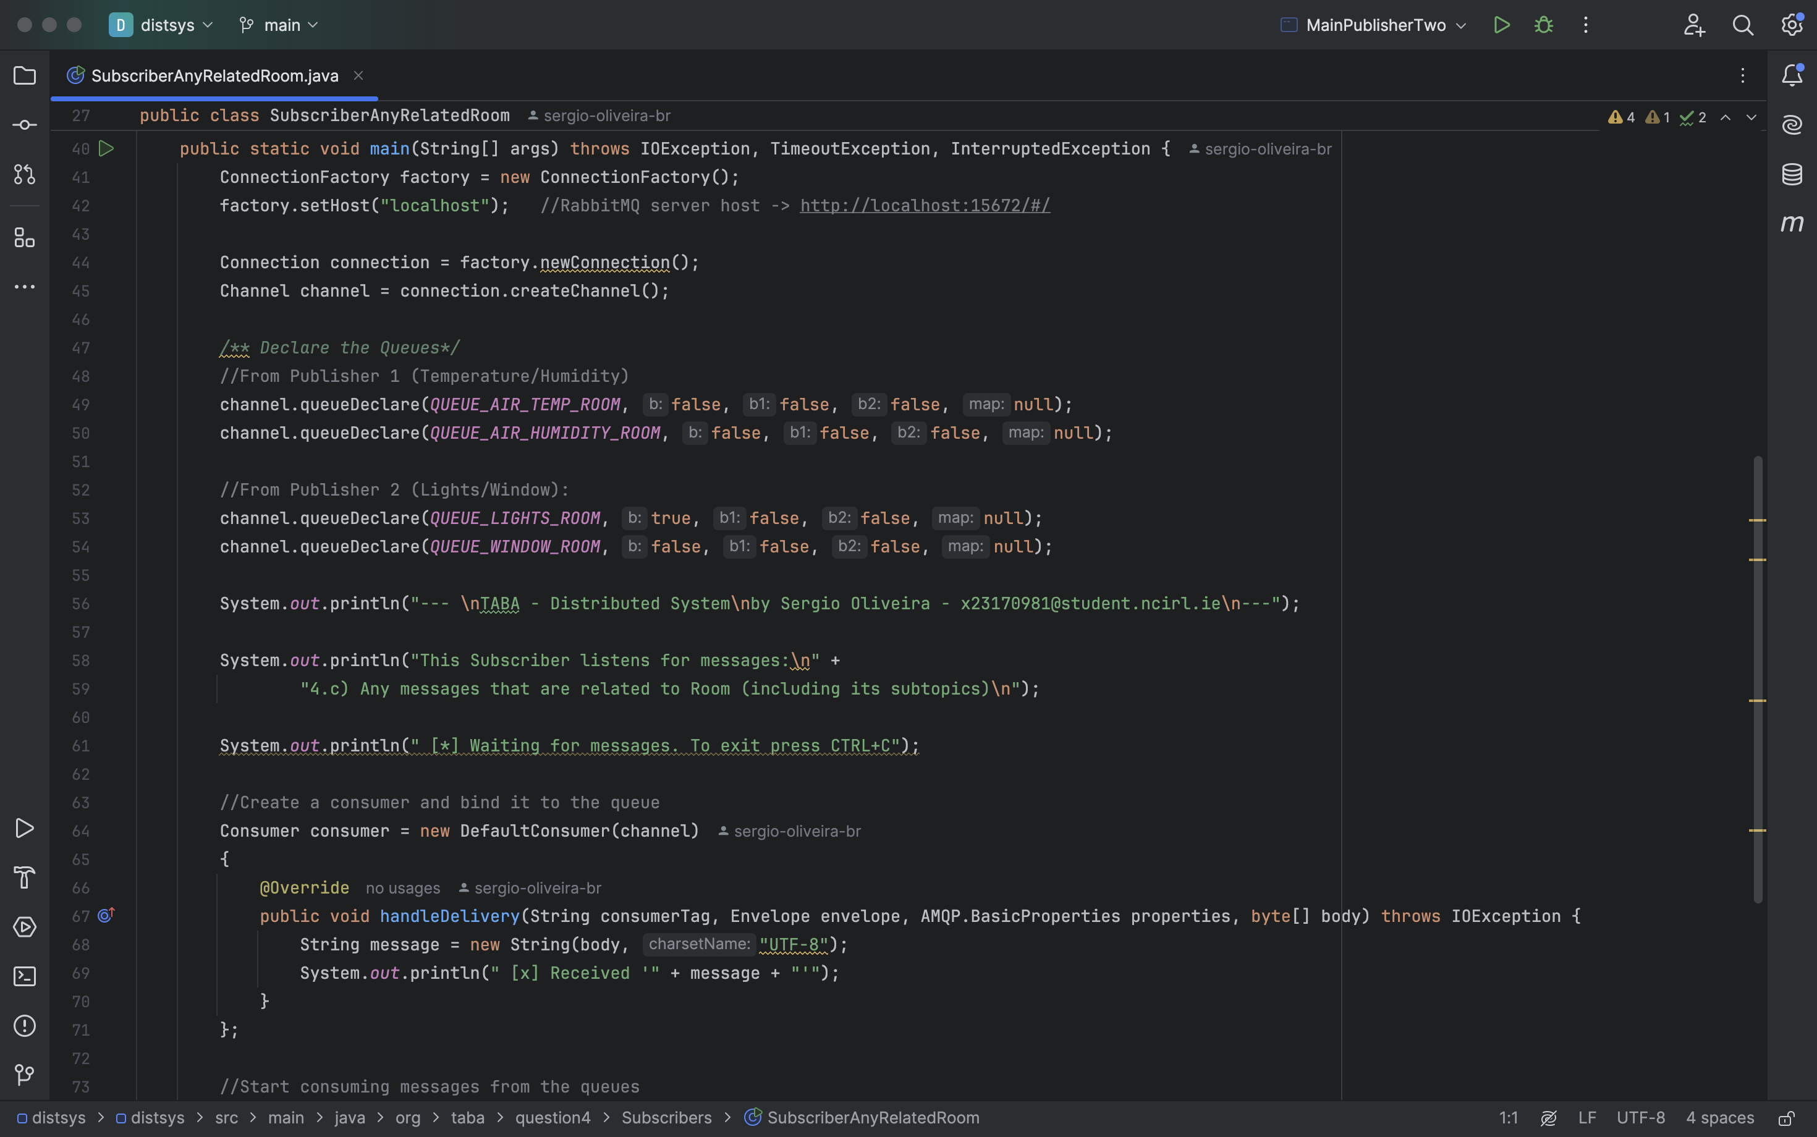

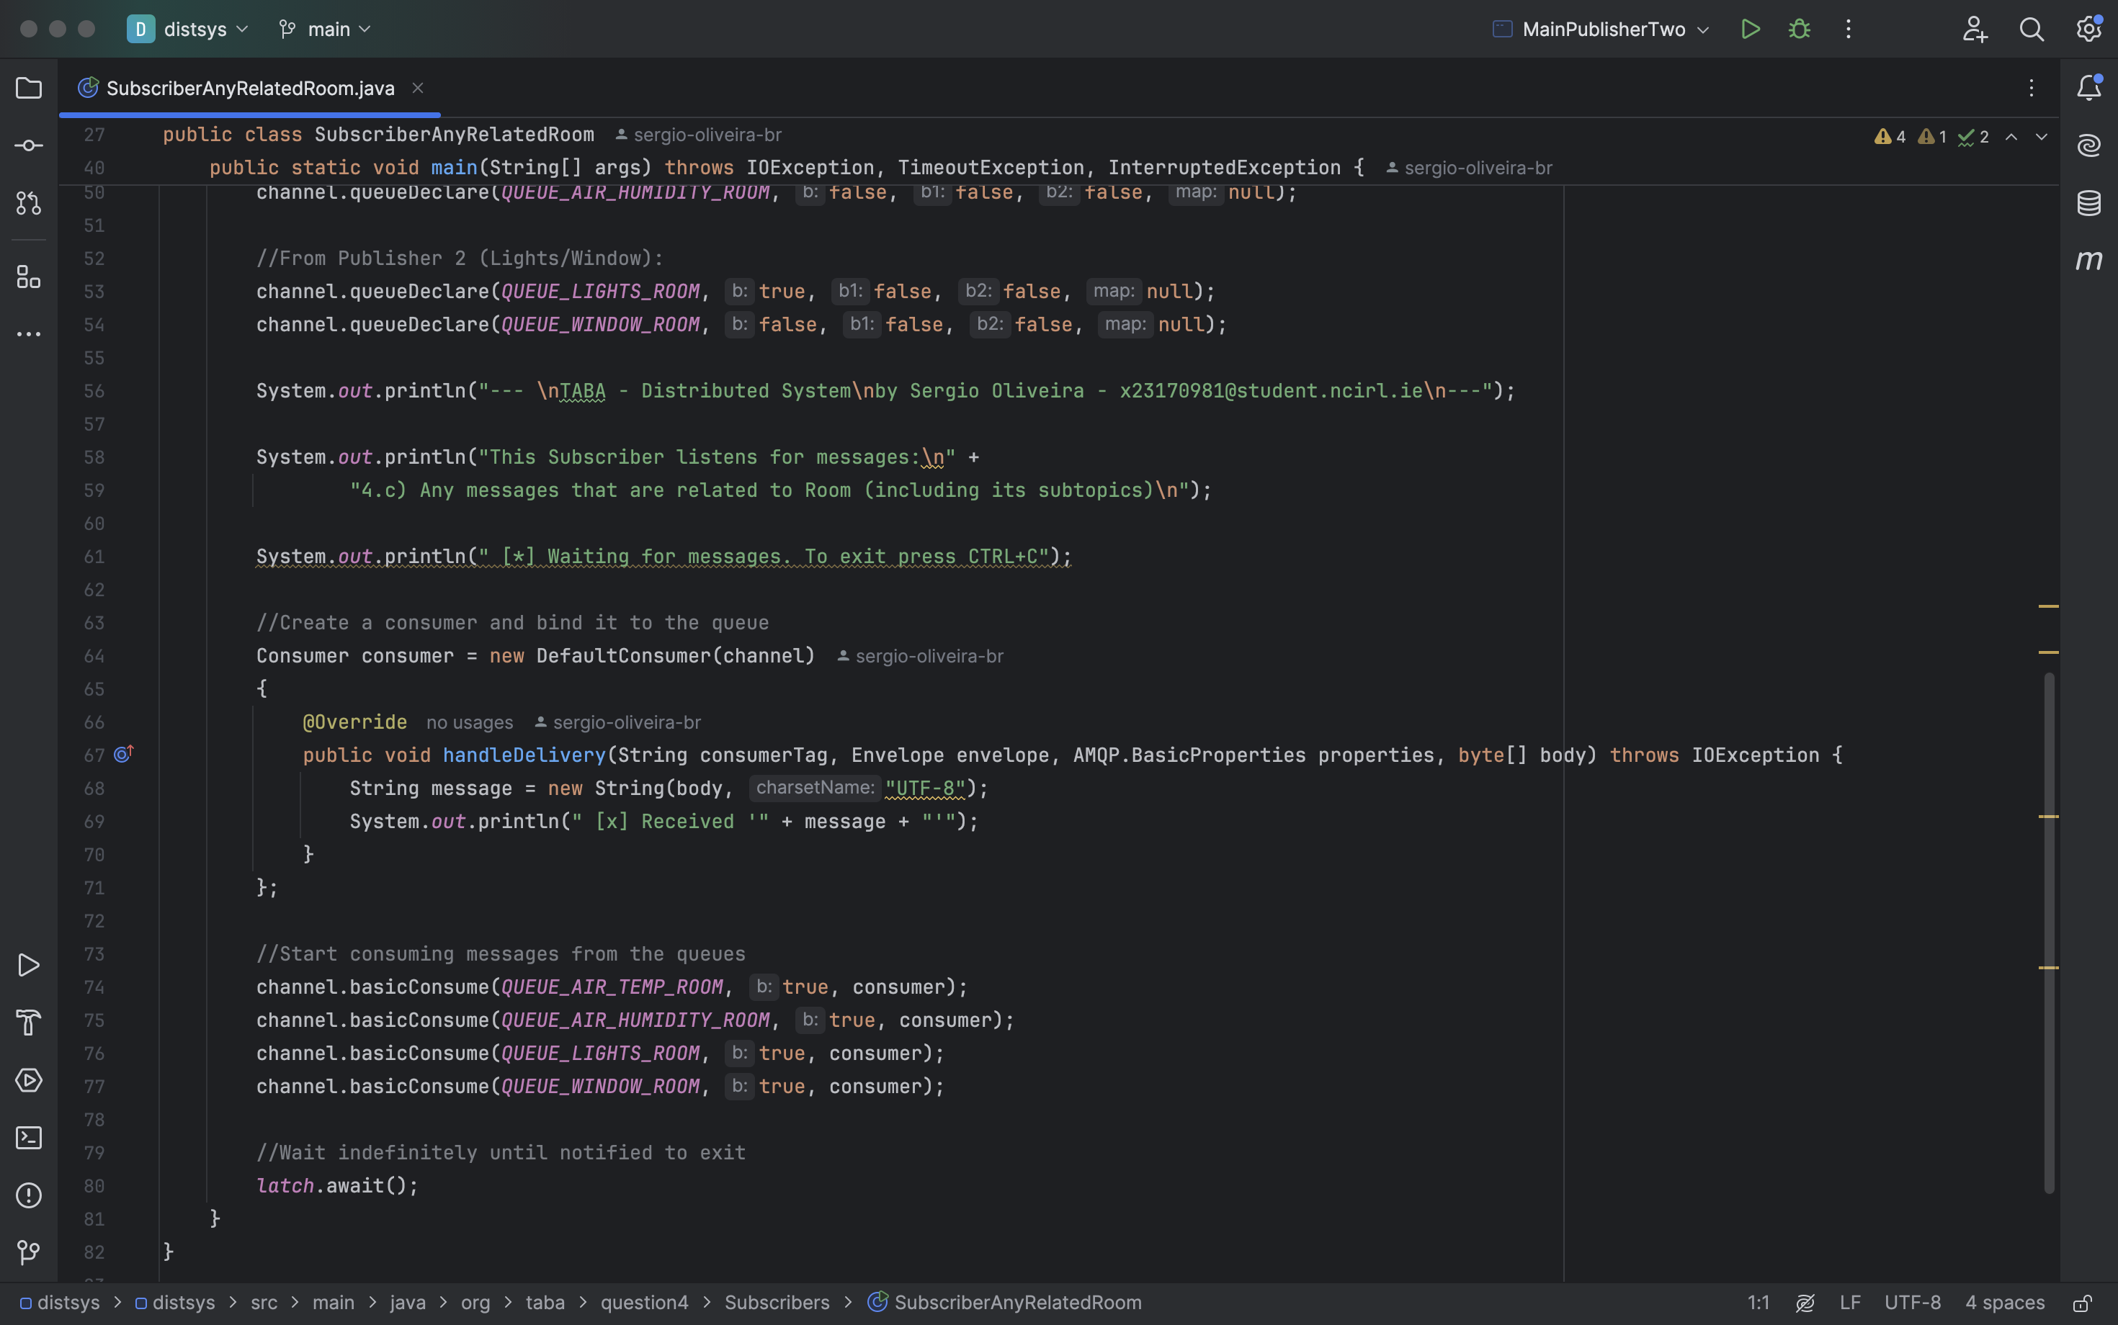

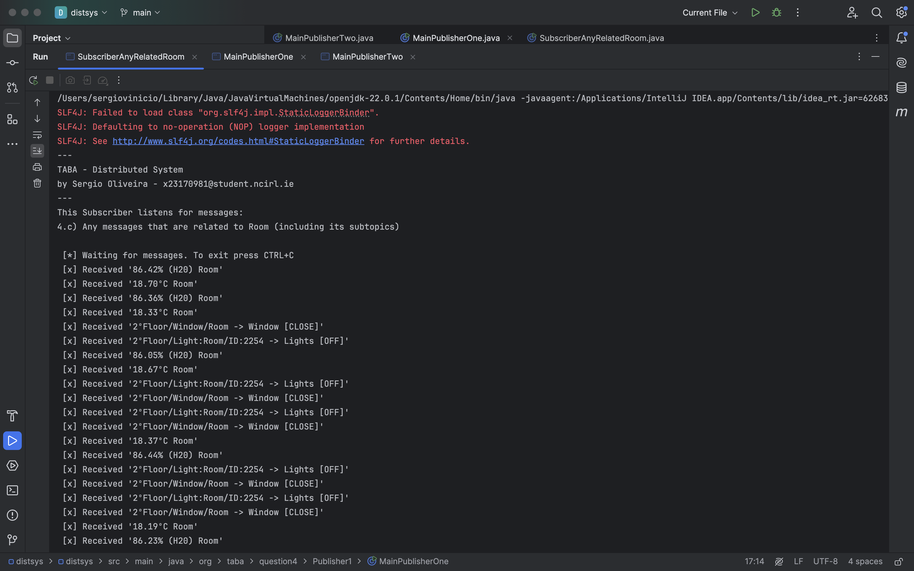

1. **Messages that are related to the floor for both light and window.**

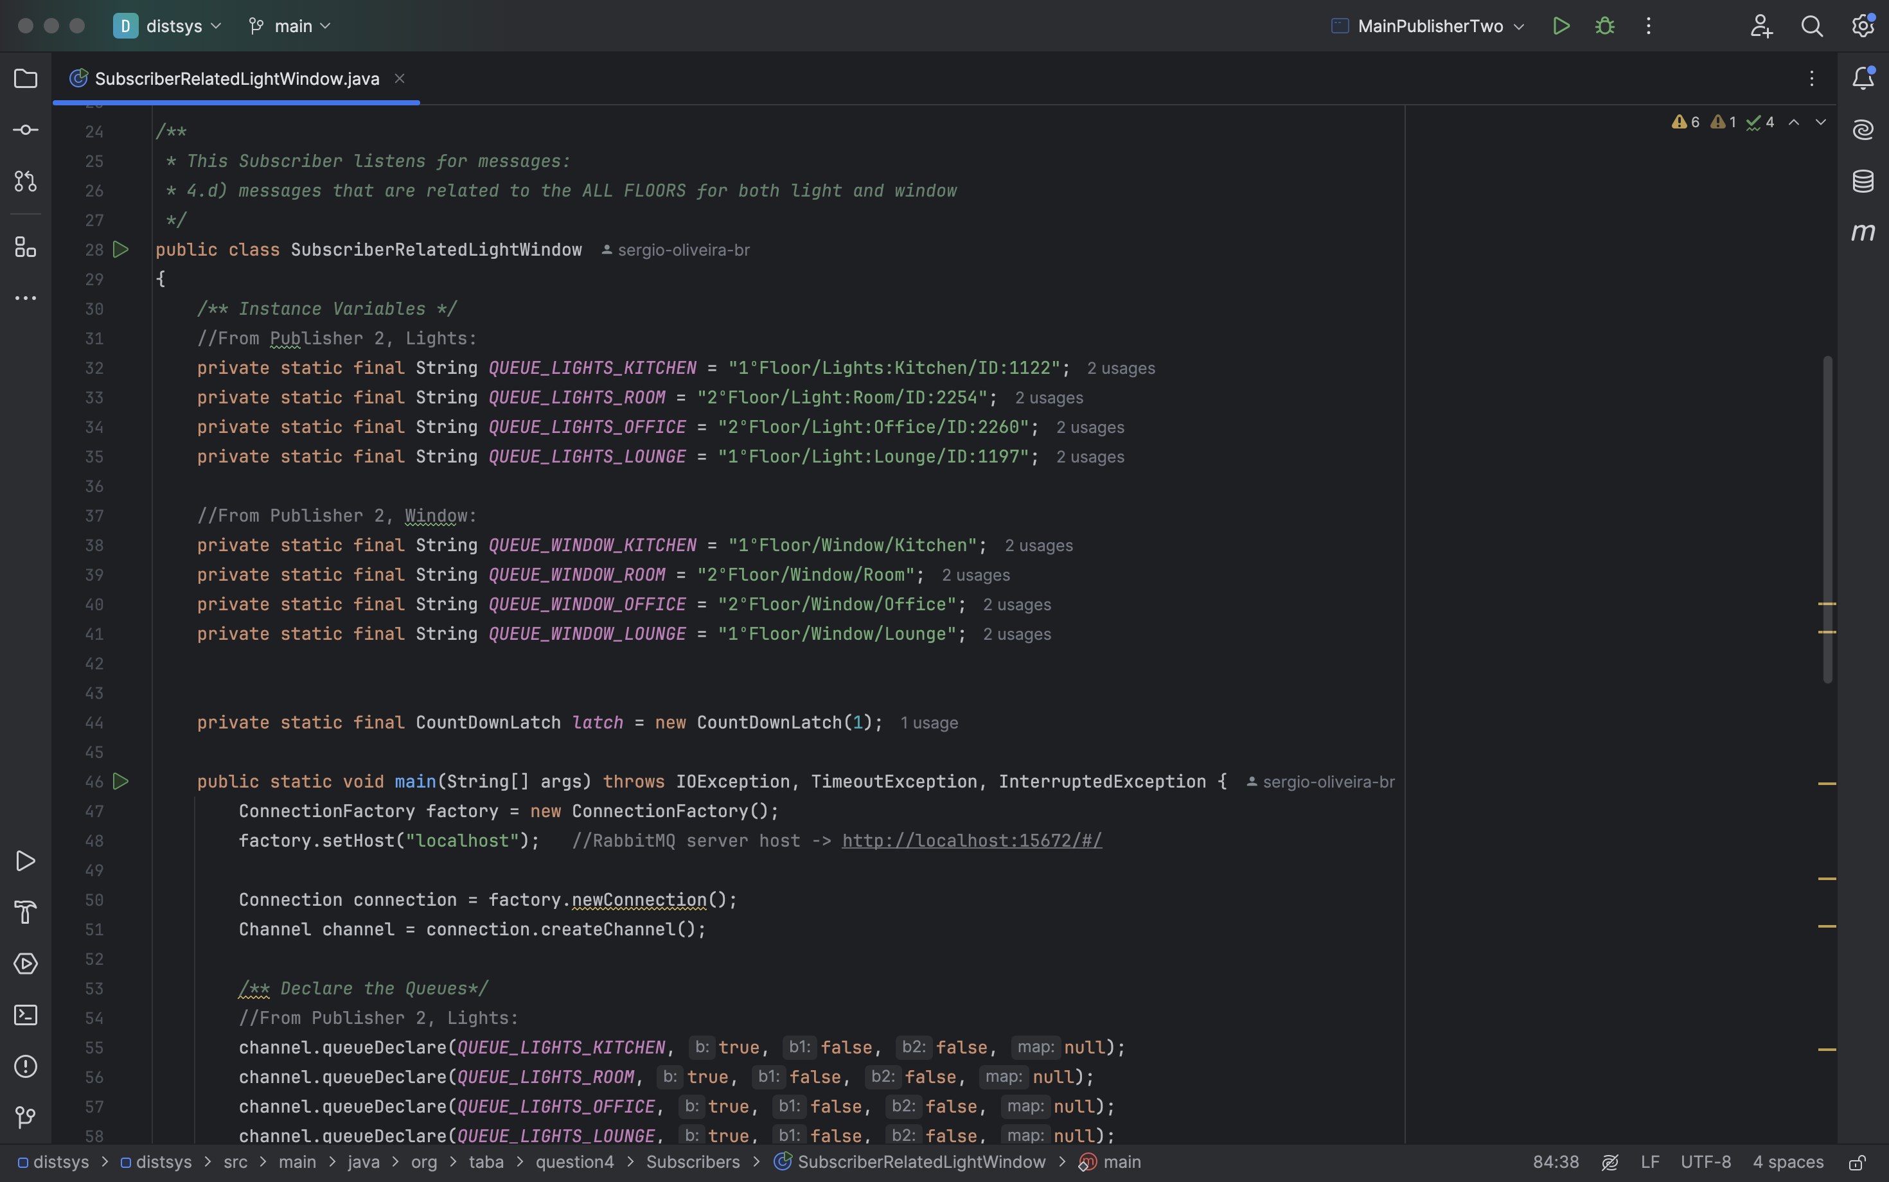

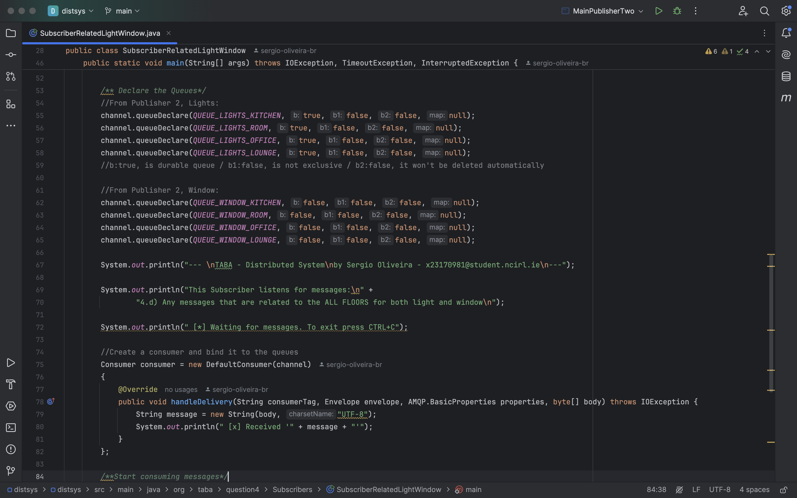

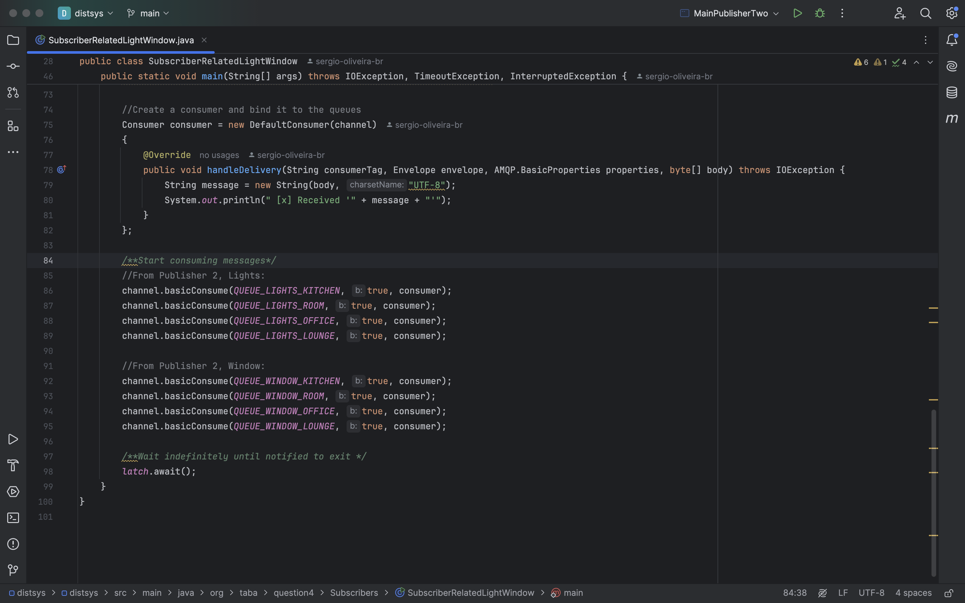

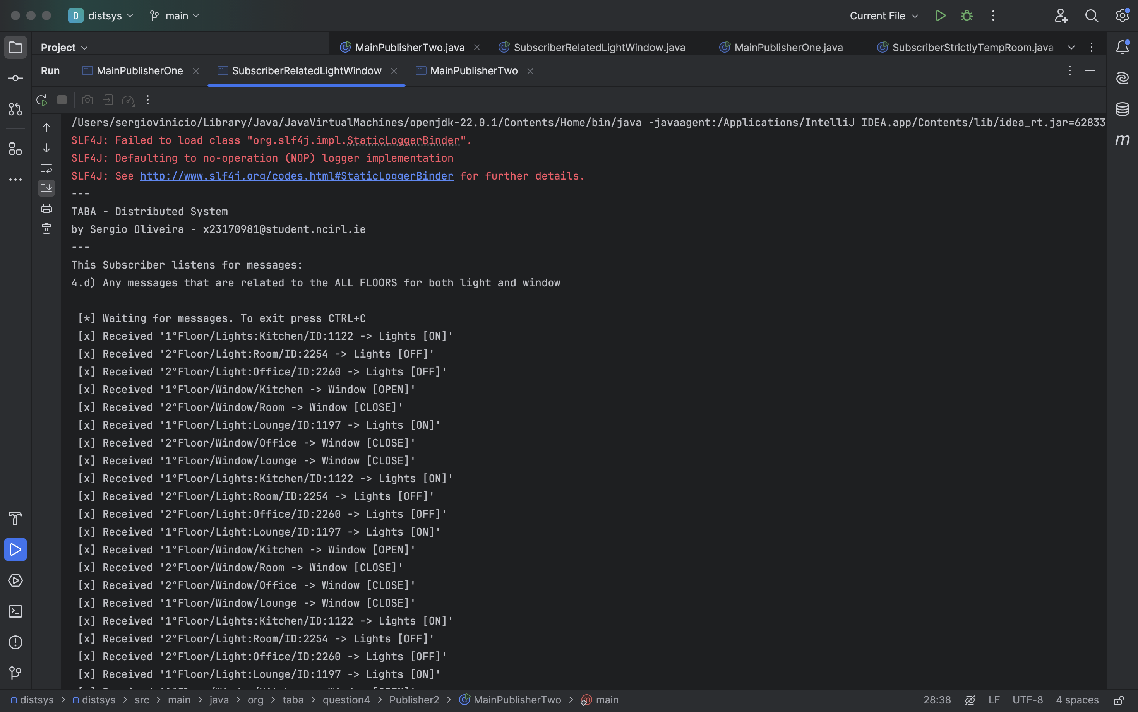

1. **Finally, show and explain how you can facilitate disconnected clients.**

*I struggled to understand this question.*

I understand that the theme concerns the situation of messages sent from the publisher to subscribers who are disconnected at the time of publication.

When receiving published reports is vital for the client, the Deliver Auto Ack method enables the configuration of this parameter.

The structure of the method can be seen in the image below.

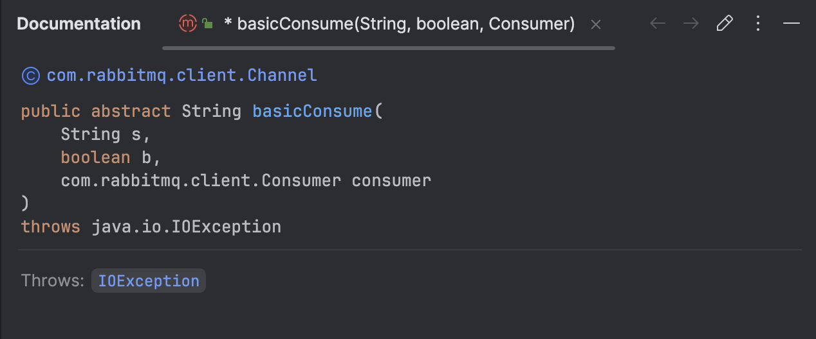

The Boolean parameter enables this auto-receive, triggering all messages published by the publisher to be stored. Once the client establishes its connection as a server, it will be downloaded.

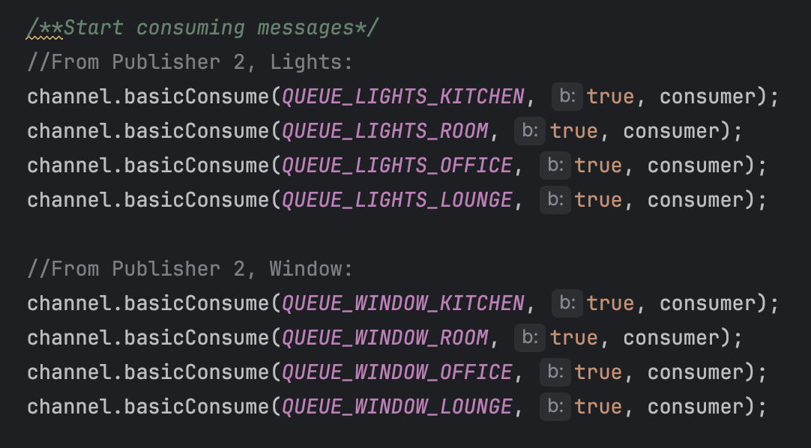

Through the image below, we can see that the publisher is sending messages at a rate of 24 seconds, thanks to RabbitMQ's monitoring features.

Other resources that can be viewed include the number of messages sent, established connections, existing queues, and more.

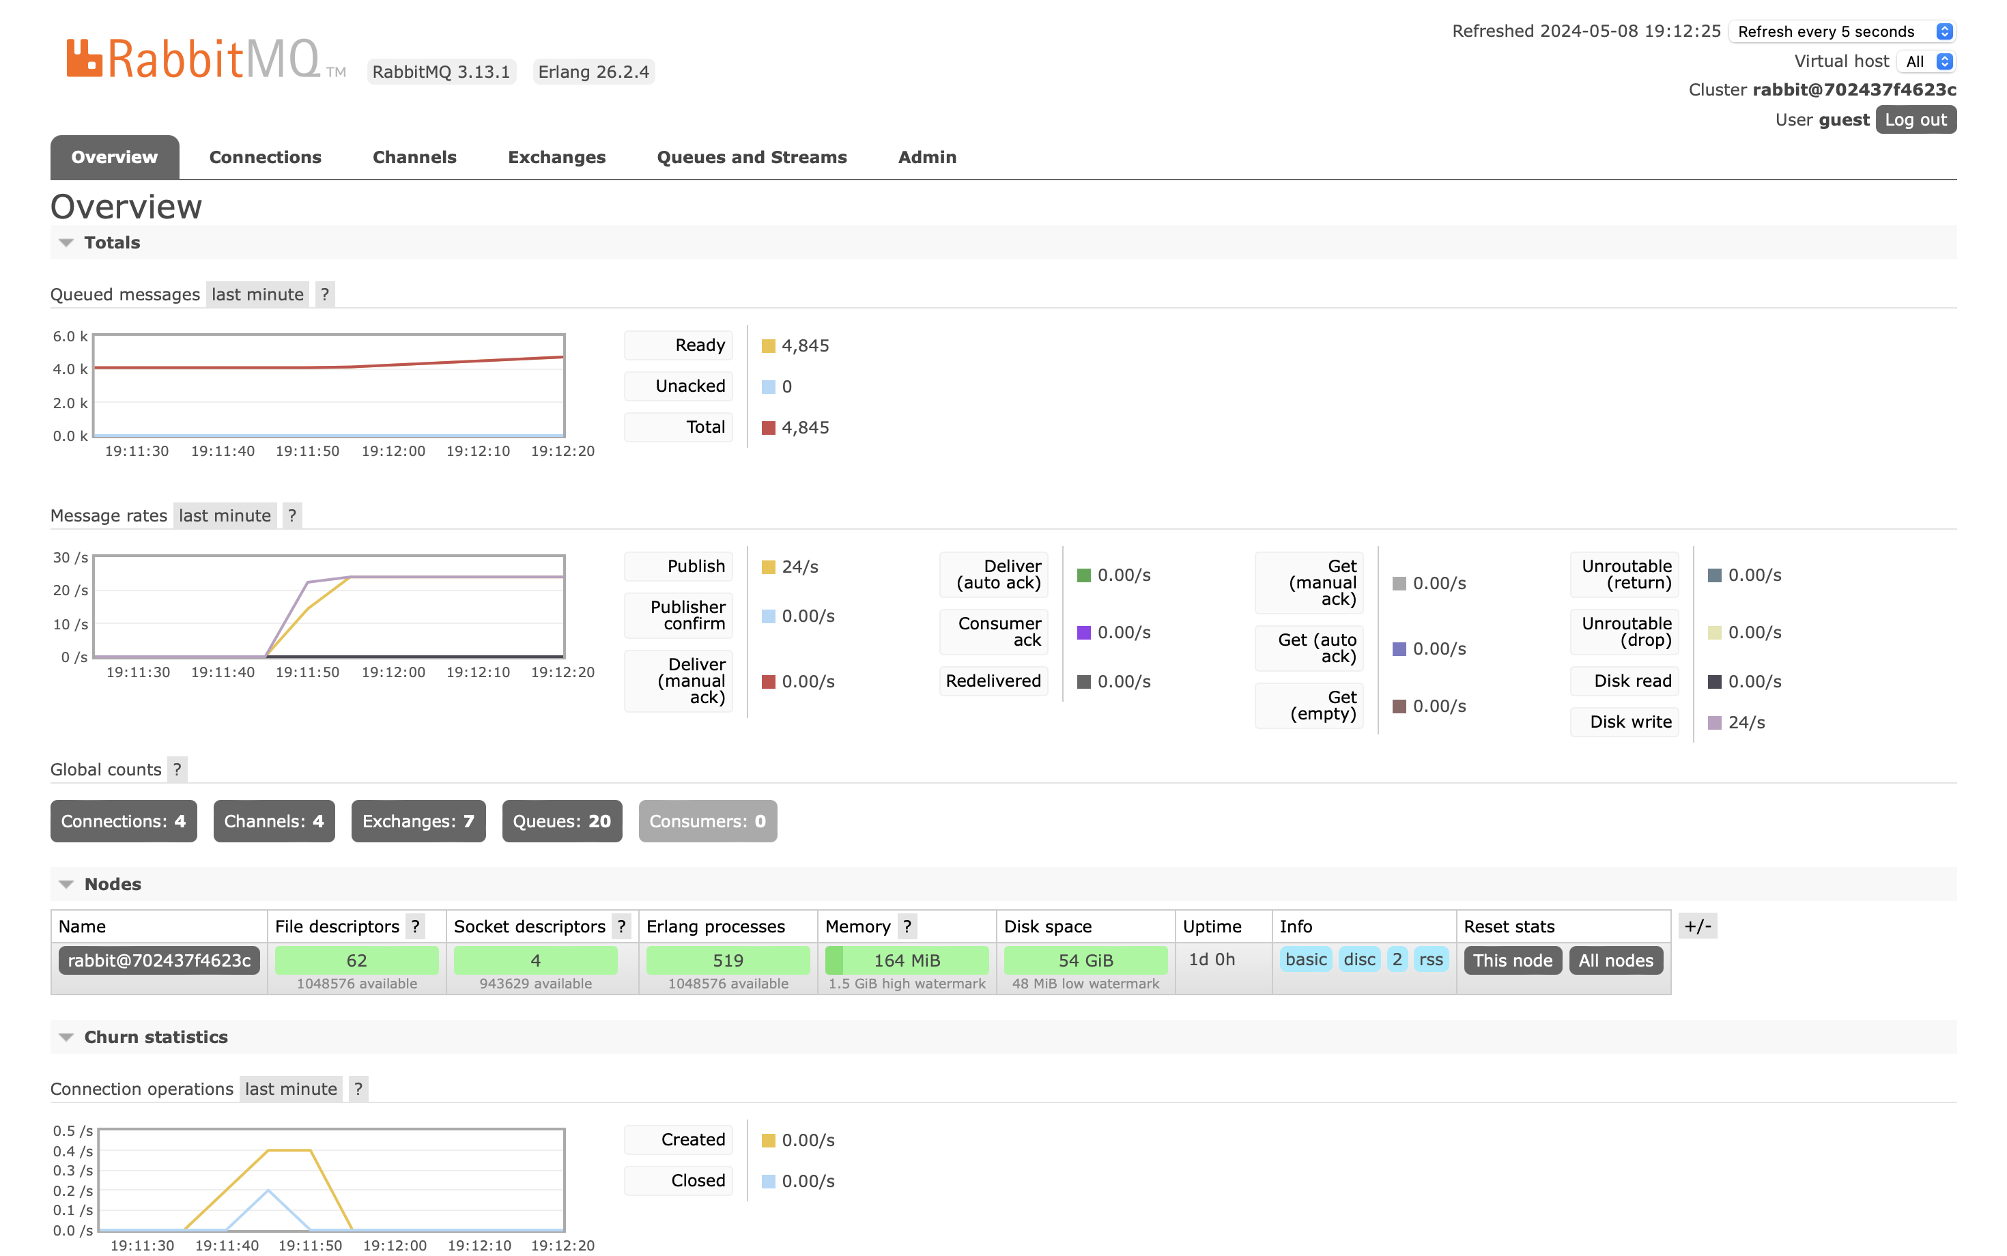

In the image below, the Deliver Auto Ack is indicated by the green line.

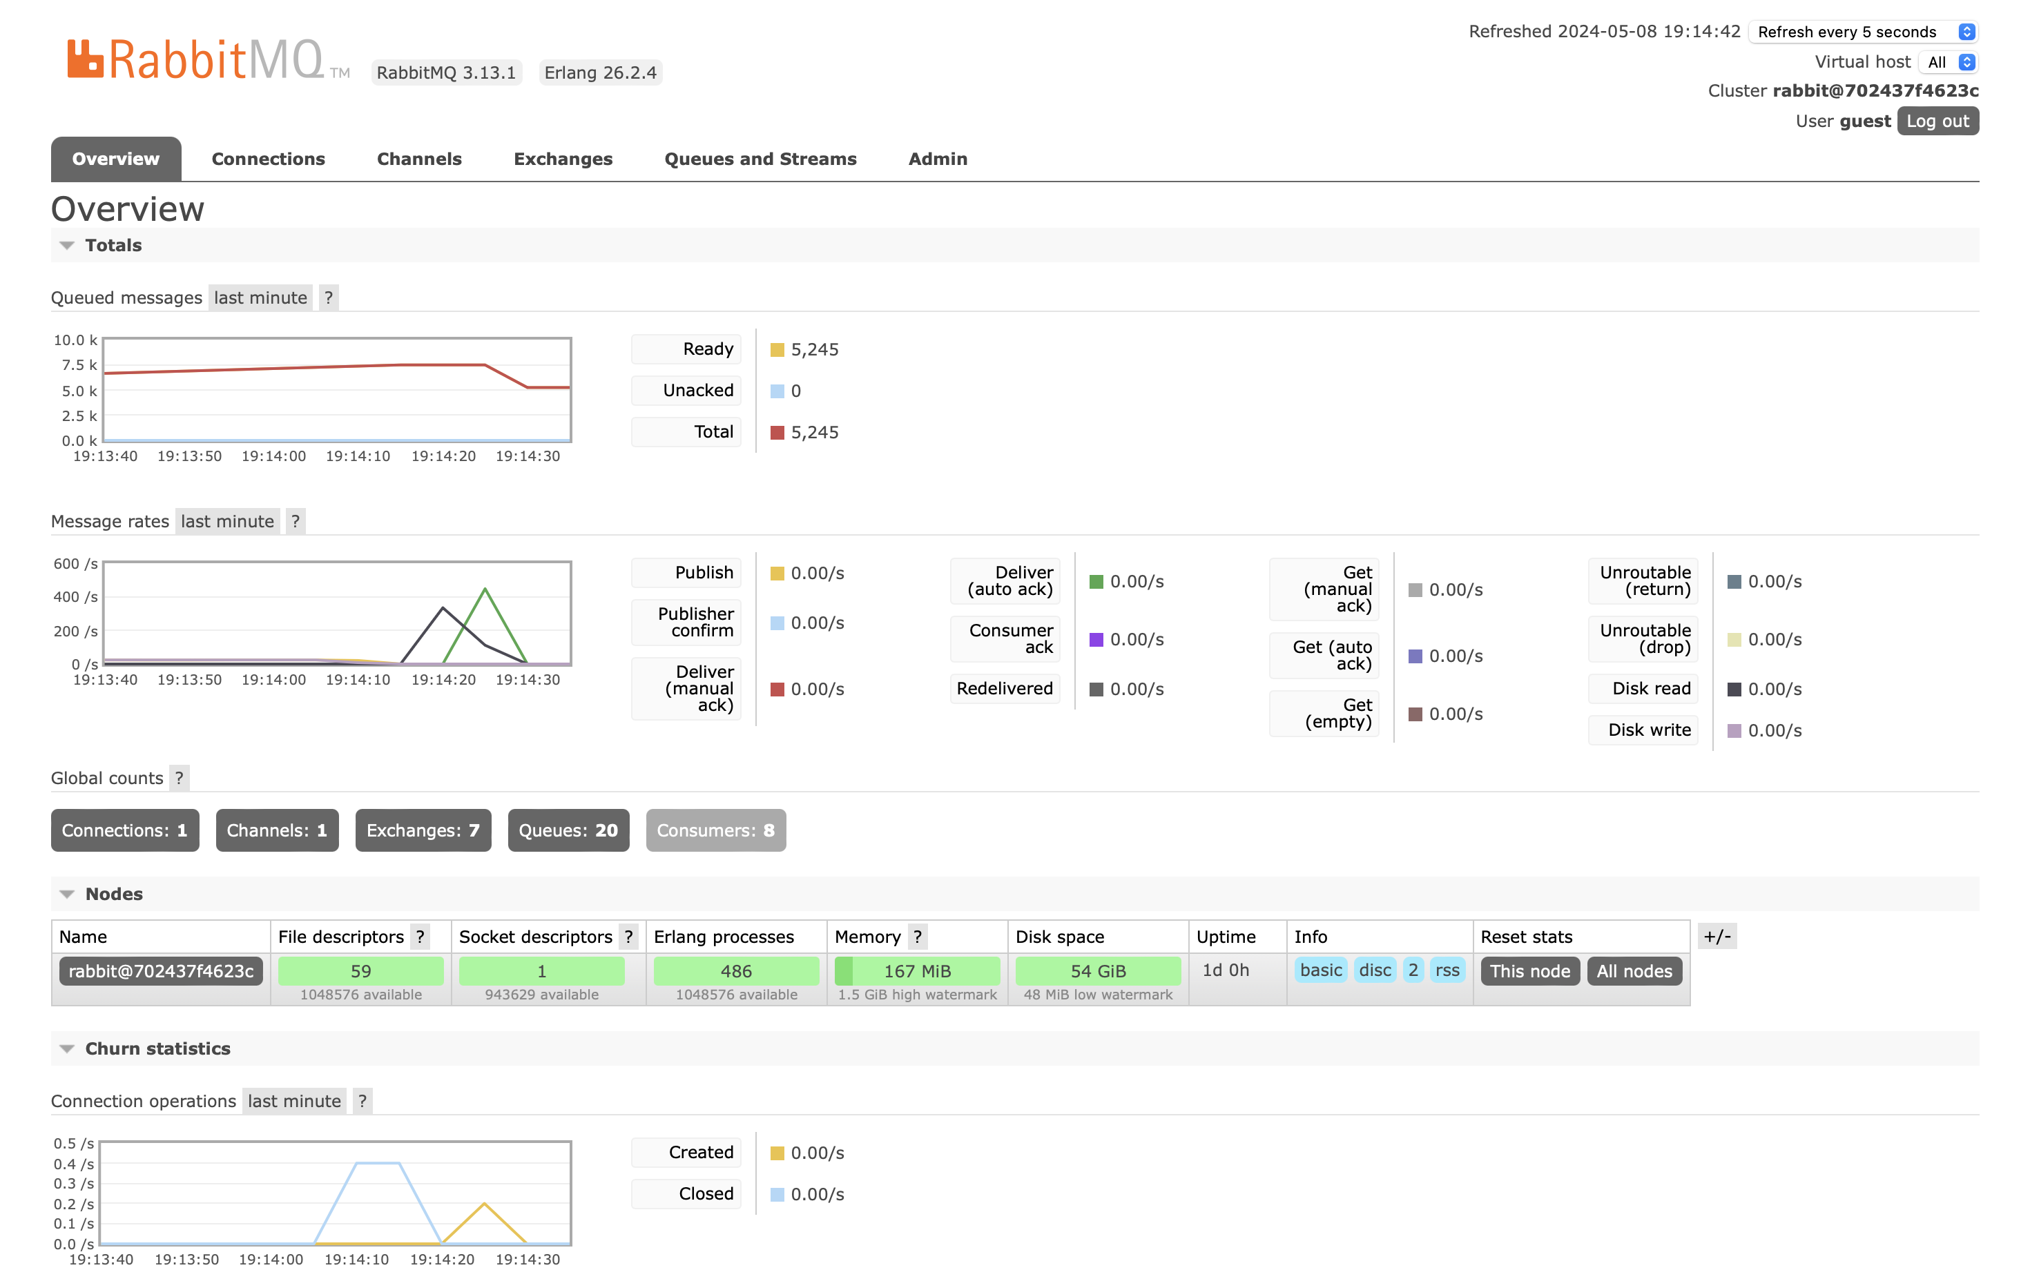

**5.a) Conceptually demonstrate a simple client-server application/scenario, including and details about the relations and interactions among the following components.**

In essence, a connection is made up of three primary services, which are: Connection, Client Sends, Client Receives.

For instance, I will make use of Sockets technology.

A socket is an object that represents a network connection between two machines, establishing a *relationship* between two software, and enabling *communication* between them.

“Socket connection means the two machines have information about each other, including network location (IP address) and TCP port.”

Kathy Sierra, Bert Bates (2005) *Head First Java*. 2end edn. Sebastopol, CA: O’Reilly.”

By extending this concept, we can incorporate *middleware* into the relationship between the client and server, acting as an intermediate layer that facilitates communication between the two.

The objective of Middleware is to facilitate the development of distributed systems, and it can perform roles such as, validation and security functions, among others.

Due to the presence of this middleware, the client connects to it, which then connects to the server. In this scenario, the middleware receives the information that the user intends to transmit and manipulate it as needed before transmitting it to the server.

In addition, Middleware also plays a key role in *registry* connected clients by recording client information, and details of that sessions.

As a result, Middleware is essential not only for client-server communication but also for managing client connections.

This relationship can be demonstrated through the image below.

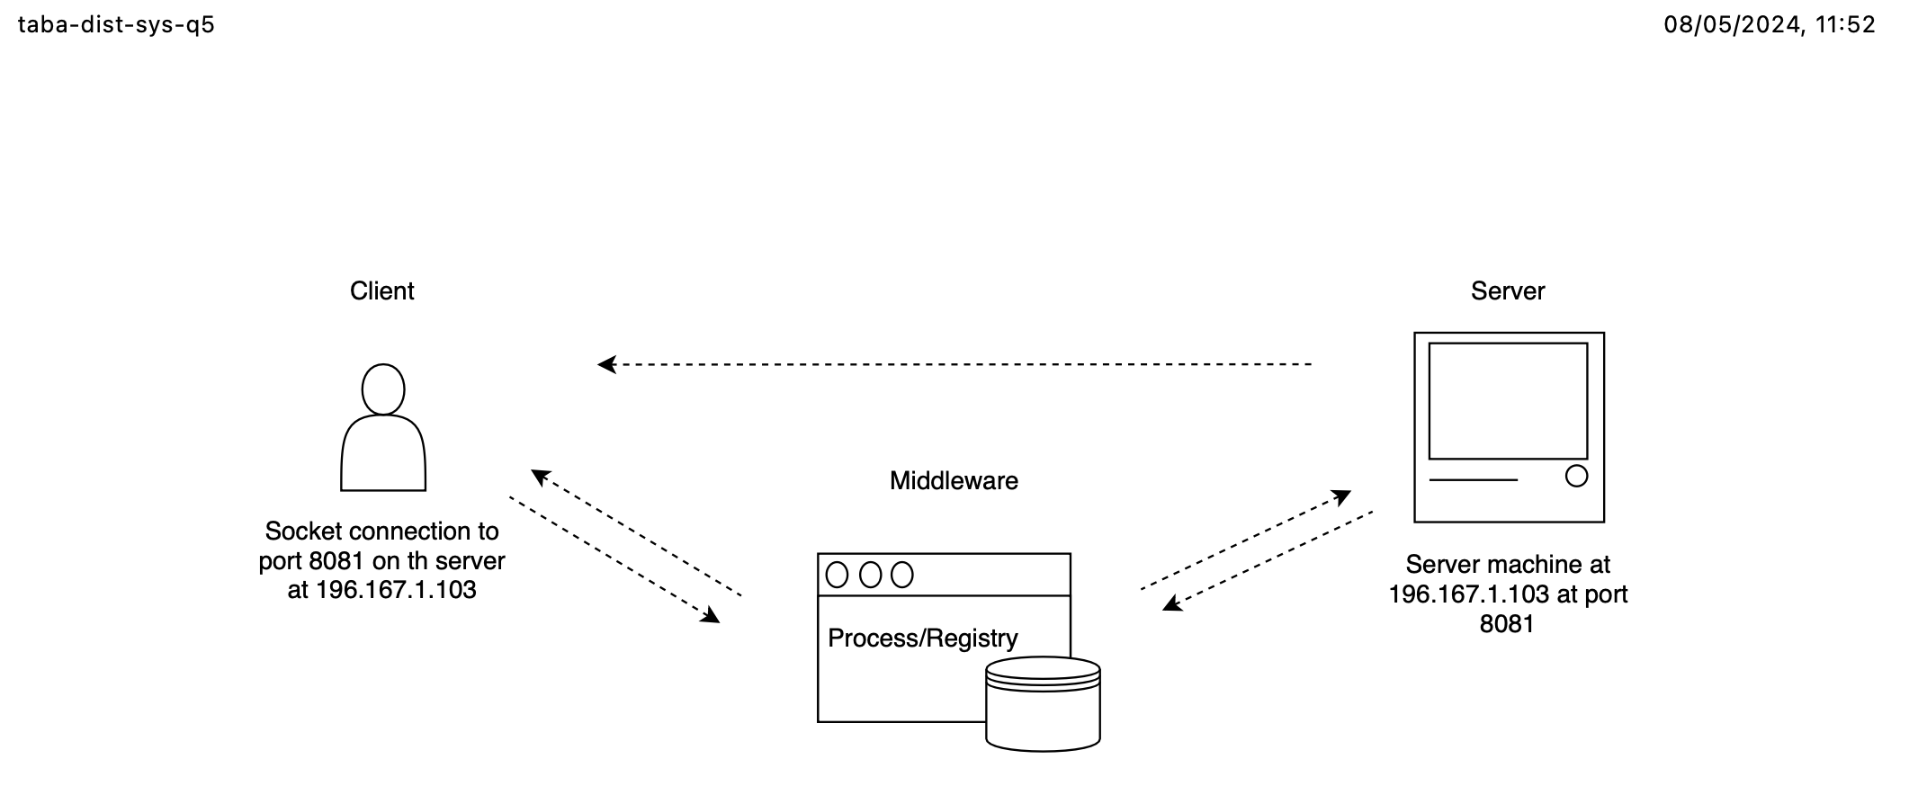

In a chat program, this concept can be used to create a hypothetical scenario. The image below demonstrates in 4 steps the process of interaction between clients and servers using the Socket environment. In other words, it summarizes what was discussed earlier.

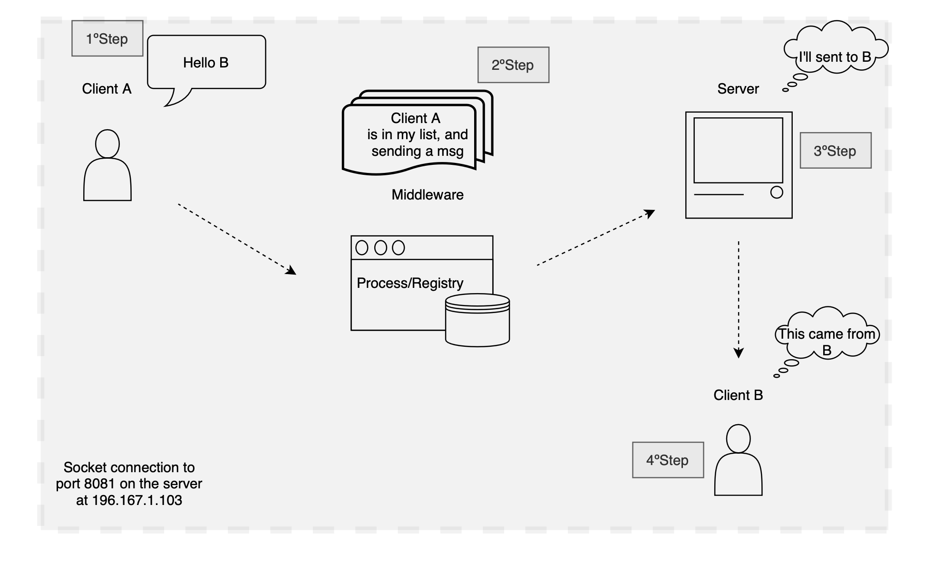

**5.b) Investigate and report how cloud-based systems balance the trade-offs of the PACELC theorem, and what approaches they take to guarantee Consistency, Availability and Partition Tolerance.**

The PACELC theorem extends from the CAP theorem. Through the image below is possible get a brief overview of the CAP theorem, highlighting the three pillars.

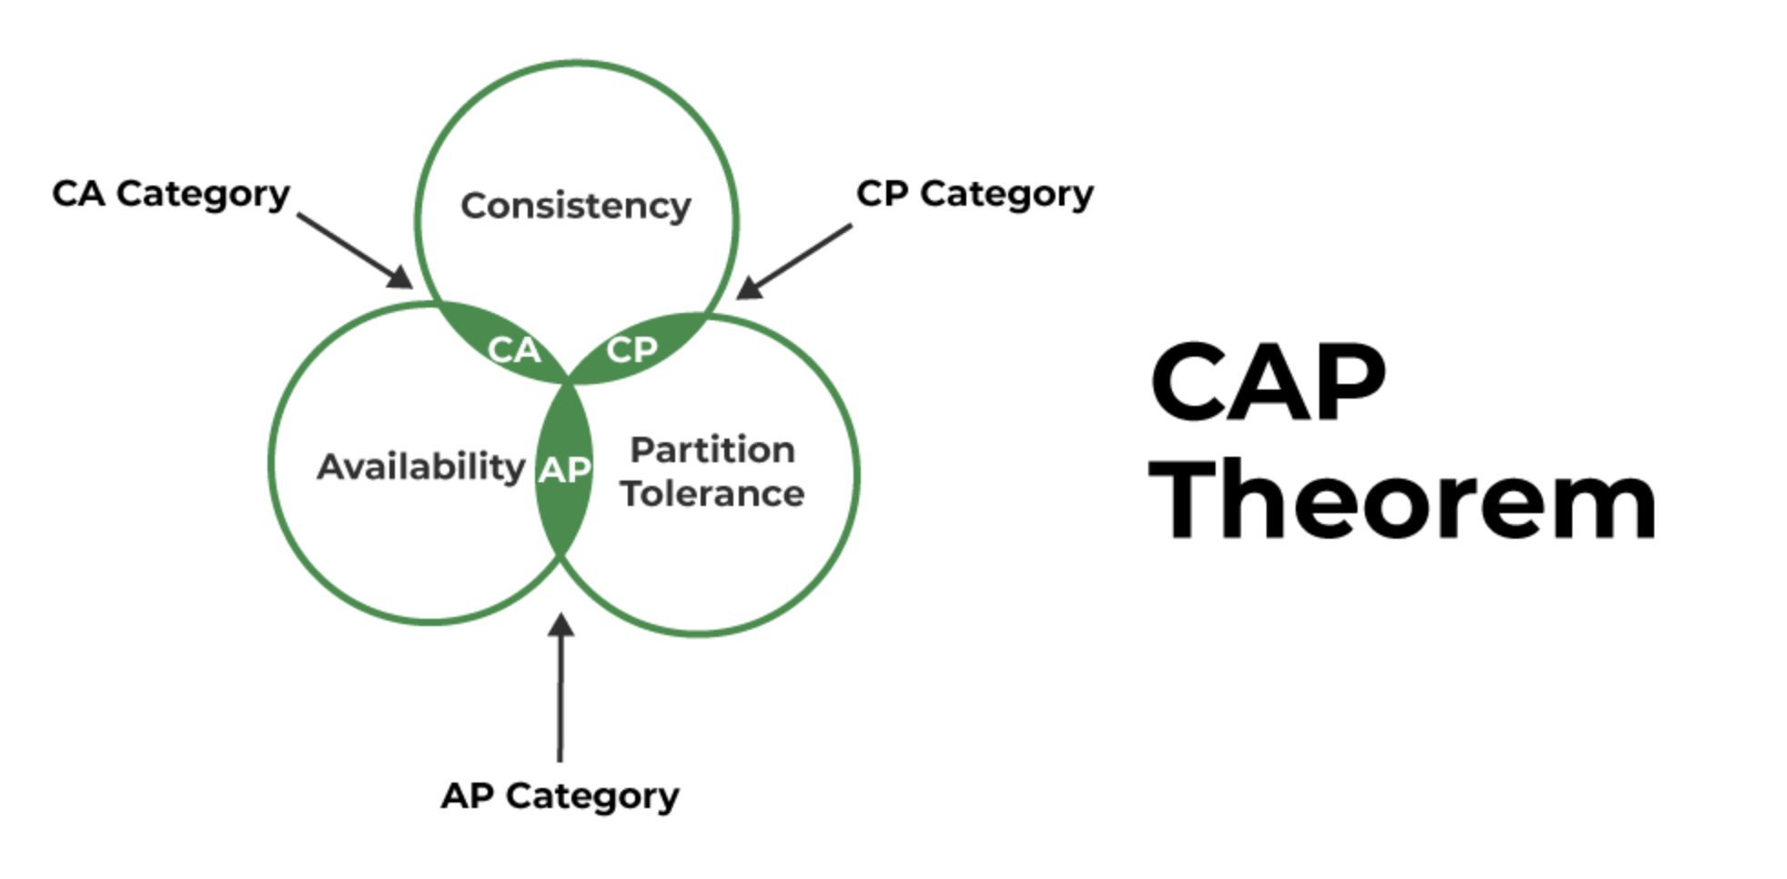

Geeks for Geeks (2022) PACELC Theorem. Available at: <https://www.geeksforgeeks.org/pacelc-theorem/>

[Accessed 08 May 2024].

The acronym PACELC stands for Partitioned, Availability, Consistency Else Latency, Consistency, is designed to introduce subtle details that increase the complexity and interest of distributed systems.

The PACELC theorem indicates that in case of Network Partition ('P'), a distributed system may present offsets between Availability ('A') and Consistency ('C'). Else(‘E’) if there is no network partition, offsets can occur between Latency ('L') and Consistency ('C').

This concept can be seen in the image below.

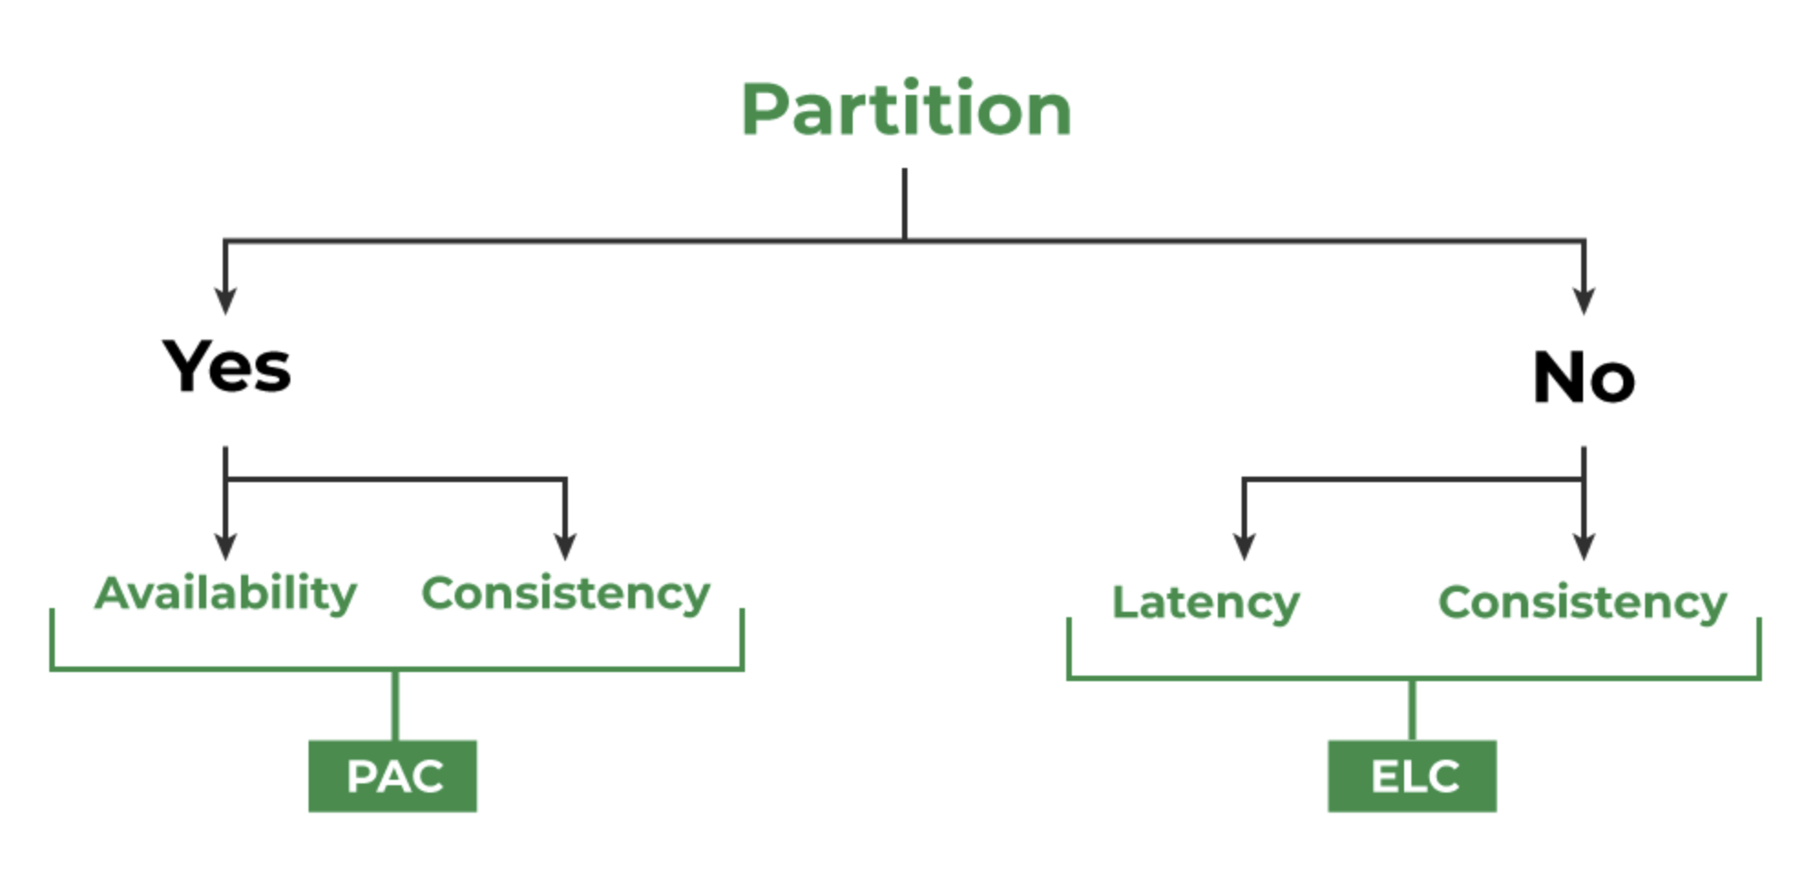

Geeks for Geeks (2022) PACELC Theorem. Available at: <https://www.geeksforgeeks.org/pacelc-theorem/>

[Accessed 08 May 2024]

The PACELC theorem is different from the CAP theorem because CAP doesn't give any trade-offs regardless of whether the system is operating normally or not.

To illustrate this idea, consider a scenario in which the user makes a registration request to access a simple website, but in this case the website only confirms your access hours later. According to the CAP theorem, this system is available, but such latency is unacceptable in any real-world application, which is why PACELC was created, to consider the latency and consistency trade-offs that were always prevalent.

Strategies and techniques exist for ensuring consistency, availability, and partition tolerance.

The strategy involves, Replication and Redundancy, Quorum-based Systems, Failure Detection and Recovery, and Consistency Models.

Techniques such as, duplicate data and services across multiple nodes to minimize single points of failure, helps to prevent partitions from impacting data and services, or distributing incoming requests equally will prevent server overhead, and others, such as, Scalability, Global Distribution, and Fault Detection and Recovery are some techniques that work together with the strategies mentioned earlier.

Due to the complexity generated by factors such as system architecture, interdependencies between components and evolving business requirements, we must keep in mind that seeking the balance between robustness and simplicity, it is essential to ensure the PAC.

In view of this, we can conclude that approaches such as, implementing layers of abstraction and modular design principles to keep complexity isolated and manage dependencies, using automation tools for deployment, monitoring, and scaling can help reduce manual intervention and streamline operations, and implementation of microservices architecture to split large systems into manageable components, achieve the success of cloud-based structures.